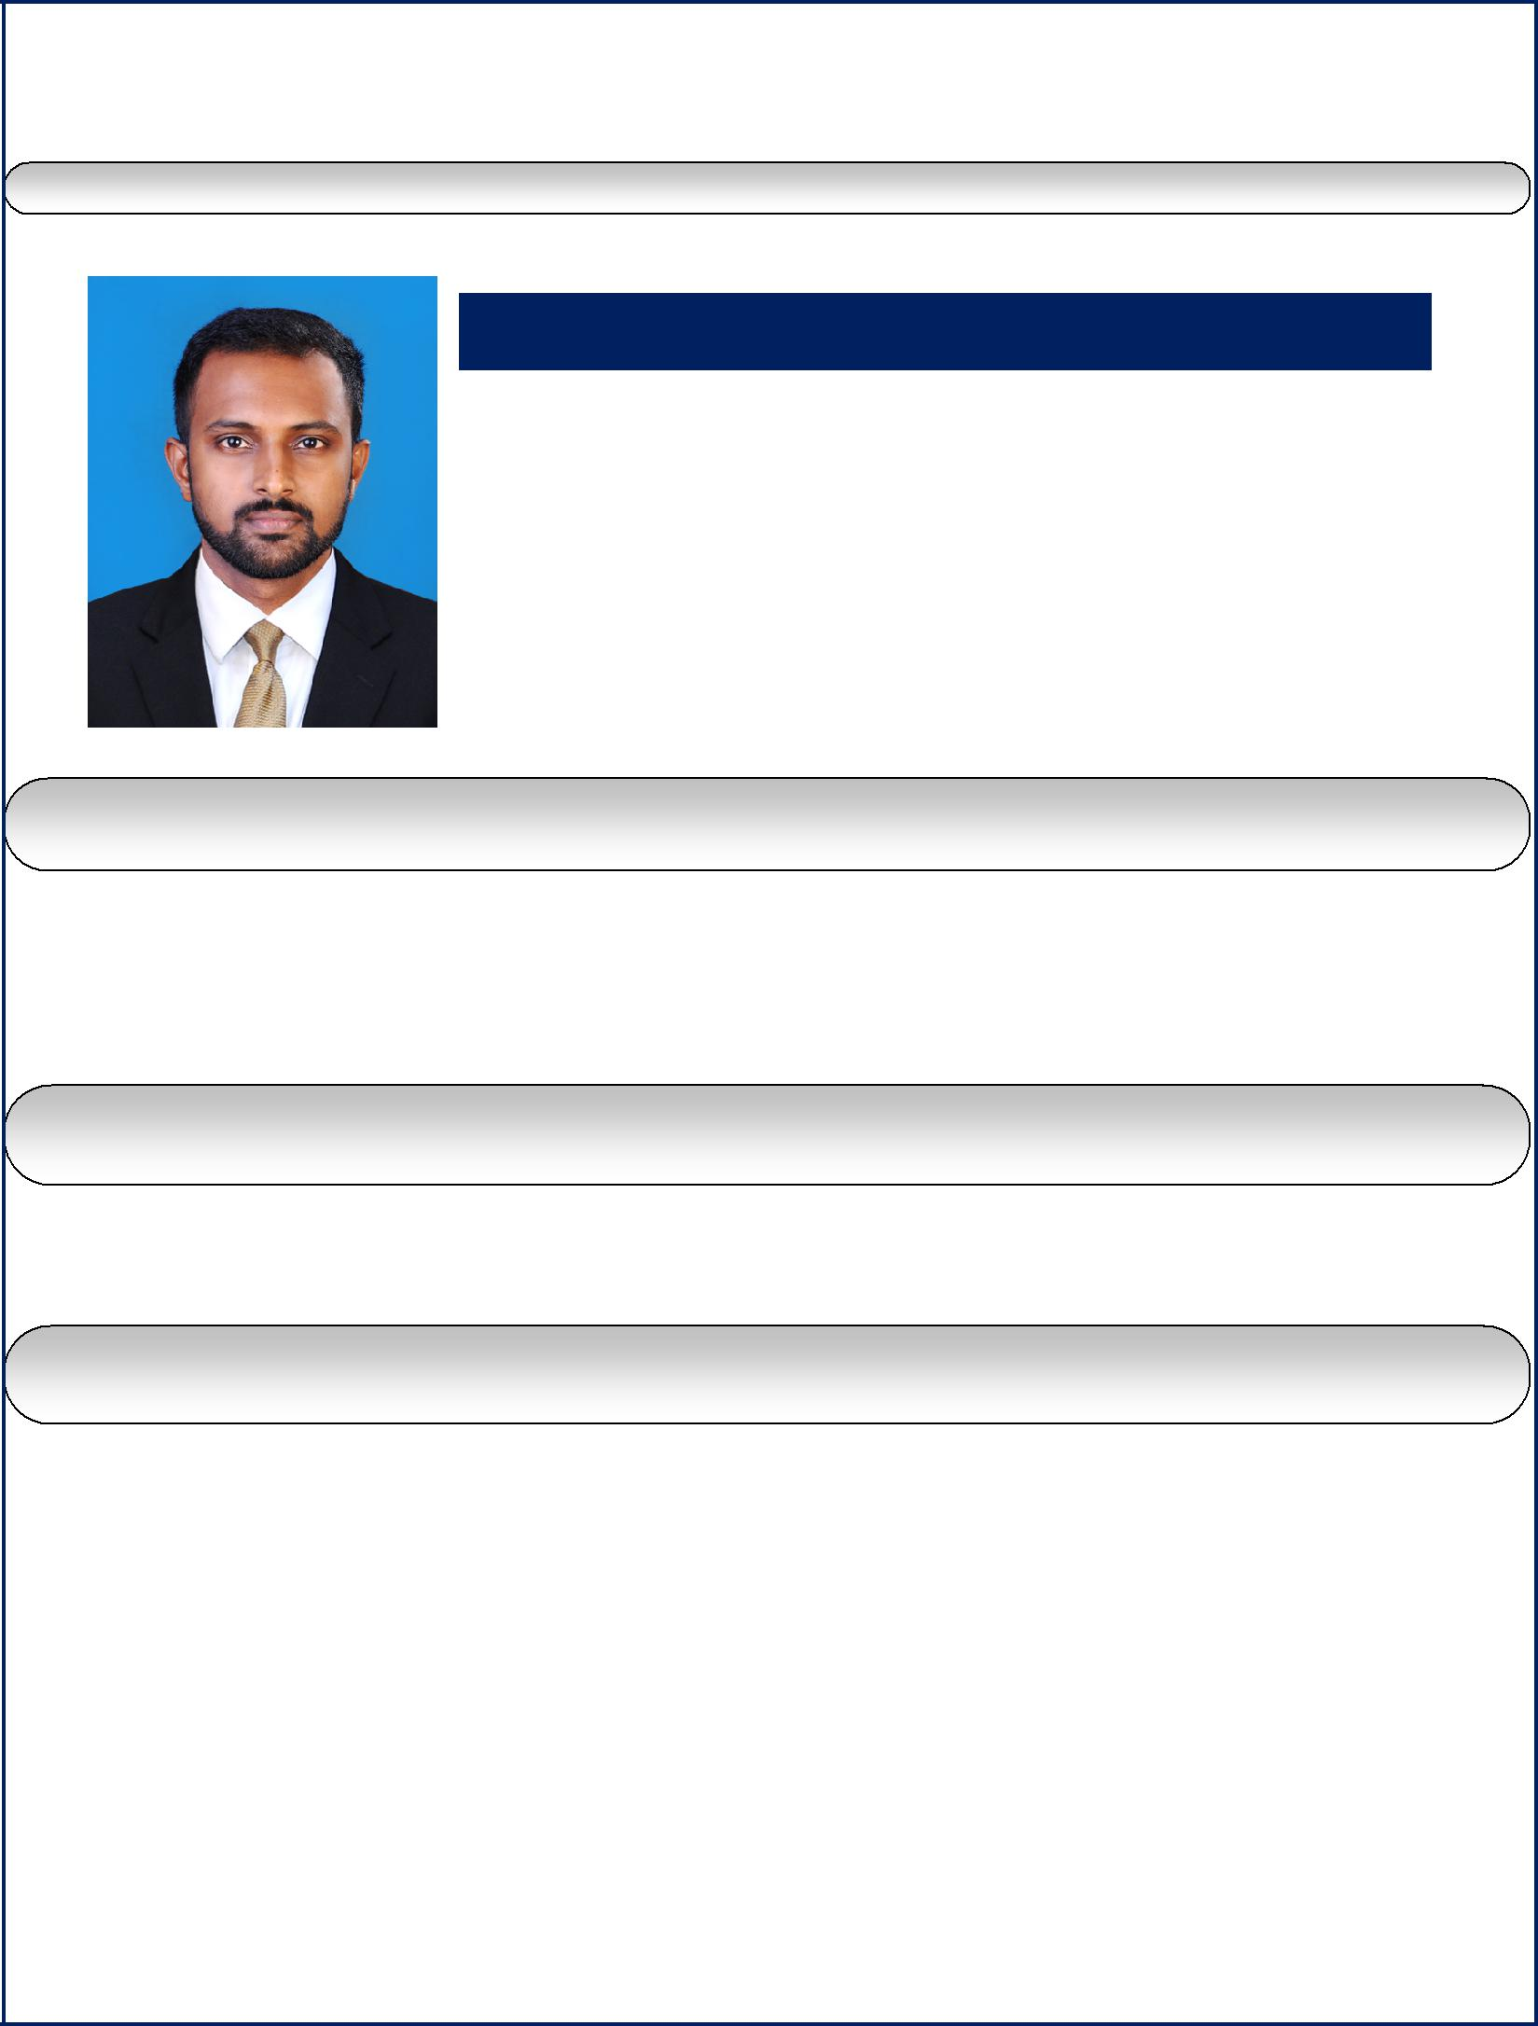
ACCOUNTANT WITH MORE THAN 2.6 YEARS PROFESSIONAL EXPERIENCE

SUBIN

Current Location: Qatar

Contact No: C/o 971504973598

Subin.378468@2freemail.com

CAREER OBJECTIVE

To build a strong and successful career in Accounts & Finance and to take responsibilities and fulfill them to the very extend I can.

WORK EXPERIENCE

Accountant

Theruvath Builders, Kerala, India (June 2015 – Jan 2018)

JOB PROFILE

- Passing Journal entries & Maintain balances of subsidiary accounts by verifying, allocating, posting, reconciling transactions & resolving discrepancies

- Maintain tax(VAT) payments & support VAT implementations

- Verifying related supporting documents like quotation, purchase orders, delivery notes, store receipt, Receipt Vouchers, Deposit slips & cheque copies etc

- Manage cash & Cash equivalents & control liquidity

- Analyze and maintain customer account ,supplier account, Out standings and review age wise analysis

- Preparing bank reconciliation as well as debtors and creditors accounts

- Review Inventory ledger, Stock Register and physical stock verification

- Maintain Payroll And Benefits & supervising the payroll operational functions

- Perform the closing procedures for the periodical closings as monthly, quarterly and year end closings

- Preparing and reporting for the Monthly & Quarterly financial statements (T/B, P&L, B/S , Cash Flows) and accompanying analysis

- Manage and maintain fixed asset register & Depreciation

- Liaising with Managerial Staff, Bankers, Auditors & Government authorities

- Coordinate and assemble information for the annual audit and provides assistance to external auditors in the review of financial operations

- Perform other related duties as instructed by the Management

EDUCATIONAL QUALIFICATION

Master of International Business(Commerce)-(MIB) Bharathiar

university, Tamilnadu, India

Bachelor of Commerce(B.Com), M G university, Kerala, India Certificate of International Financial Accounting
(Institute of International Accountants, India)

I T SKILLS

- Microsoft Office Packages

- Accounting packages – Tally ERP 9, Peachtree and Finac

- Confident to do any Accounting Software

PROFESSIONAL SKILLS

- Organizing tasks

- Positive Attitude

- Leadership/Management Skills.

- Planning

- Problem-Solving/Reasoning
- Teamwork

- Honesty

PERSONAL DETAILS

Date of Birth

Gender

Nationality

Marital status

Religion

Languages known

Visa Status

: 27/04/1989

: Male

: Indian

: Single

: Christian

: English, Malayalam and Tamil

: Visit Visa

REFERENCE

Reference will be provided on demand.

