JANOOP

Janoop.378472@2freemail.com

Mob: C/o 971504973598

ABUDHABI

PERSONAL PROFILE

Date of Birth : 03th February 1993

Nationality : Indian

Gender : Male

Marital Status : Married

Visa Status : Visit visa

CURRICULUM VITAE
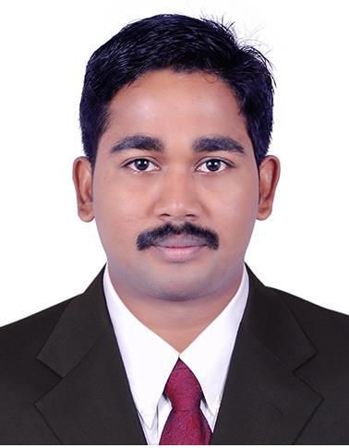

Objective

To associate myself with an organization, that provides me an opportunity to express my ideas, improve my knowledge and to be a part of the team that works dynamically towards the growth of the organization.

Academic Profile

EXAM/DEGREE | INSTITUTION | YEAR OF | PERCENTAGE/
 |  | COMPLETION | CGPA
 | M P M M SN TRUST
B COM | COLLEGE, |  | 65%
(FINANCE) | SHORANUR, | 2014
 | PALAKKAD
PLUS TWO
IN | GJHSS,NADUVATTAM, | 2011 | 62%
COMMERCE | PALAKKAD (DT)
SSLC | GJHSS,NADUVATTAM, | 2009 | 60%
 | PALAKKAD(DT)

COMPUTER KNOWLEDGE:

- Tally

- MSOffice (Word, Excel & Power point)

- Accounting software(Inventory BIZ,MK Soft)

- TYPING SKILLS

INTEREST AND HOBBIES:

- Playing Cricket

- Listening music

- Driving

- Watching TV

MY ASSETS

- Honesty

- Self confidence

- Willingness to learn.

- Hard Working.

- Positive Minded.

- Team spirit

INTERSTED FIELD

- Accounting

- Administration

- Office work

- Cashier

EXPERIENCE

3.7 YEARS WORKING AS AN ACCOUNTANT

  - One and half year experience as an accountant in– JMASSH DOORS & WINDOWS PVT

LTD. PALAKKAD.

  - One year and two months working as an accountant in – EDAPPAYIL PAINTS &
HARDWARE, Valanchery,MALAPPURAM.

  - One year experience as an accountant in – U.K.M.TIMBERS,Palathara,Pallipurampo),P ALAKKAD(DT).

- Direct reporting to Chief Accountant.

- Maintenance of journal voucher, payment voucher, receipt voucher & general voucher.

- Preparation of sales invoices, credit notes and debit notes.

- Handling day-to-day cash transactions.

- Online preparation of K VAT and monitoring to charge the correct rate of VAT, Excise Duty and remit the same to the Government.

- Responsible to deduct income tax on employee’s salaries, contractors, proffessionals, and remit the same in time to the Government and filling the returns.

- Involved in computerization of accounts in Tally Erp 9.

- Involved in internal auditing of the company.

- Preparation of payroll.

- Preparation of trial balance, profit& loss account & balance sheet.

- Preparation of bank reconciliation statement.

LANGUAGES KNOWN:

➢ English (Speak, Read & Write)
- Malayalam (Speak, Read & Write)

➢ Hindi ( Speak,Read & Write)
➢ Tamil (Speak)

PROJECT WORKS

- 3 months project on the topic “A study on the

AYURVEDIC PRODUCT IN VYDYAMADAM

VYADYASALA AND NURSING HOME,MEZHATHUR,KOOTANAD,PALAKKA D DISTRICT,KERALA.

DECLARATION

I hereby declare that the above furnished information is true and correct to the best of my knowledge and belief.

Place:

Date: JANOOP

