CURRICULUM VITAE
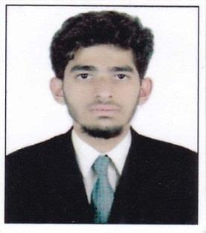

Sameer (Electrical Engineer)

Current Location: Dubai, UAE
Mobile: C/o 971501685421
E-mail: sameer.378545@2freemail.com

Careers Objective

Looking for an Electrical Site Engineer Position with a Construction Company where I can use my skills to achieve my goals & targets. I am capable of adjusting myself to any environment.

Working Experience

Worked as an Electrical Site Engineer for 2 years with S.E.A Construction, India.

– Feb ’16 – Jan ‘18

Project: G+5 Residential Building in India.

Duties and Responsibilities

- Receiving design drawings and Estimation of Quantities.

- Preparation of shop drawings and detail material requisition accordingly.

- Coordinate with consultant for the approval of the shop drawing as per local Authority requirement.

- Assign targets for accomplishment and ensure targets are met on daily basis For all electrical works at site.

- Directly Responsible for all safety of Electrical group personnel of the project By ensuring that the project execution will be done according to the applicable Health, safety and environmental Standards.

- Coordinate with HVAC and Civil trades (Architectural and Structural) for execution of Electrical installation at the time of concreting slab and starting Of block work.

- Coordinate and giving instruction to site supervisors/Foremen for all Execution of site works.

- Ensure that all site works are done as per the applicable quality standards.

- Ensure that all works done accordance with the approved construction drawings, contract documents, project Specification, and all applicable standards whether Local, national, International.

- Rising of RFI (Request for information), Inspection of Materials and IR (inspection Request) for inspection of completed works from consultant and coordinating accordingly. Rising of Variation orders if Required.

- Reporting to the project manager, operation Manager for advice for all site related issues.

- Preparing as Built drawings, O & M (operation and Maintenance) manuals, Obtain completion Certificate from the Consultant.

Educational Background

Bachelor of technology from Electrical and Electronics Trade in Jawaharlal Nehru Technological University, Hyderabad, India. (Certificate attested by Ministry of HRD, Ministry of External Affairs, Consulate of UAE) in the year of 2018

Technical Courses
- Certificate in MEP ( Mechanical, Electrical and Plumbing)

- Auto Cad.

- MS-office

- Expertise in all editions of windows & MS Office.

Strength

- Self-motivated confident & excellent management skills.

- Good Communication skills.

- Highly productive and consistent learner.

- Hardworking and Honest.

- Strong Leadership, interpersonal & Communication skills & the ability to work independently.

Personal Details

- Languages known: English, Urdu, Hindi

- Country: India

- Visit Visa

- Expiry: 19-May-2018

Declaration

I hereby declare that all the above particulars are true and correct to the best of my Knowledge

PLACE: Dubai, UAE. (SAMEER)

