ZAHID
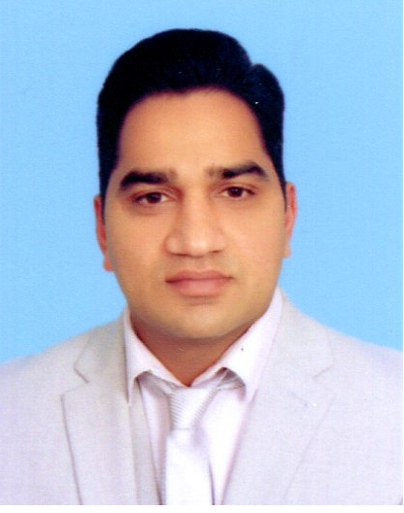

BA-Hons (UK), MBA-Finance (UK),
FInstAM (UK),MCMI (UK), AMInstLM (UK)

D.O.B: 06/01/1979 C/o- Mobile: +971504973597 Email: zahid.378548@2freemail.com

Professional Profile
A dynamic and results-driven professional with a highly successful background in accounts, management, administration and secretarial work.Committed to achieving and exceeding demanding targets and business objectives while remaining focused on providing an exceptional standard of service to our clients. Possesses excellent interpersonal, communication and computer based skills, the ability to influence decisions and to develop positive internal and external relationships. Enjoys being part of, as well as managing and motivating, a successful and productive team and thrives in highly pressurised and challenging working environments.

Formal Qualifications
MBA (Finance) awarded by Cardiff Metropolitan University, United Kingdom
Year 2015 (Pass)
BA (Hons) Business Management awarded by University of Sunderland, United Kingdom
Year 2013 (2:2)
Advance Diploma in Business Management awarded by NCFE & Central College London, UK
Year 2012 Distinction (70%)

Certifications
- Fellow of The Institute of Administrative Management, UK (FInstAM)
- Memberof Chartered Management Institute, UK (MCMI)
- Associate Memberof Institute of Leadership and Management, UK(AMInstLM)

Workshops/Seminars
- “Conflict Management” conducted by Edit Development, sponsored by SocieteGenerale Corporate & Investment Banking at Grand Connaught Rooms, London on 18/10/13.
- “Understanding Team Roles” conducted by Edit Development, sponsored by SocieteGenerale Corporate & Investment Banking at Grand Connaught Rooms London on 18/10/13.
- Participated in seminar on the topic “The Currency of Management – What managing money teaches us about managing people” speech and discussion by Professor Michael Mainelli (co-founder Z/Yen, the City of London’s leading think tank), and arranged by Chartered Management Institute (CMI) at Council Chamber, The Law Society London on 13/12/2012.

Experience in United Kingdom
Organisation: Royal Mail, Chiswick Delivery Office, London
Period: Jan, 2012 to Jan, 2016
Designation: Delivery Officer (part time)
Duties: Delivery monitoring, routes allocation, new staff training

Organisation: British Transport Police, London
Period: Mar, 2015 to Oct, 2015
Designation: Community Engagement Volunteer
Duties: Administration duties, CCTV monitoring, new police officers training, sniffer dogs training, public awareness duties at Waterloo, Euston and Shepherd’s Bush.

Experience in Home Country (Pakistan)
Organisation: SME Bank Limited (formerly Small Business Finance Corporation), Pakistan
Period: Feb, 1999 to Nov, 2009
Designations: - 4 years’ experience as Branch Chief Accountant.
- 4 years’ experience as Accounts Assistant.
- 2 year 10 months experience as Secretary to Executive VicePresident
and Assistant Administration.
Duties: - Balancing of loan portfolio
- Preparing/compliance of periodical reports (weekly, monthly, annually).
- Preparation/Compilation of books of accounts (general ledger, subsidiaries
of expenses, realized and unrealized mark-up, bank accounts etc.
- Bank reconciliations.
- Typing of general correspondence and preparing of reports on Word & Excel.
- Assistance with Head Administration for matters related to Administration
Department.

Appreciations/Achievements
- Royal Mail, London: (South-East Region – Quality of Service): Appreciation letter given by Mr. Jim Smith, Manager West London on 05/10/2013 regarding quality check on my delivery area.
- Central College London: Appreciation letter given by Ms. Candace Lafleur, Head of Centre on 27/09/2012 regarding participation as College Representative in college accreditation process with Quality Assurance Agency of United Kingdom.
- SME Bank Ltd (Pakistan): Recovery Performance Certificated given by Mr. M. Azam Khan, Head East Zone Lahore in July 2009 regarding best support to recovery teams.

Researches
- Business Development Research Proposal for development of new business titled “Electronics imports and sales by InvenTech” as MBA major project.
- Impacts of Creative and Innovative Sales Promotion on Consumer Buying Behaviour in the context of 21st Century Business.
- Business Proposal for Schuke Technologies Ltd, Italy

Language and Computer Skills
- Fluent in English (speaking, listening, reading, writing)
- Urdu, Punjabi
- MS Office (Word, Excel, PowerPoint), Outlook, Internet browsing, basic web designing, Inpage Urdu, Peachtree.
- Typing speed 50 WPM

References
- References both based in Pakistan and United Kingdom available on demand.

