Faresh

DUBAI, UAE | C/o 971506425478 | faresh.378550@2freemail.com

Professional Summary

A dedicated and energetic professional with 3 years experience in Marketing & Sales, Business Development and Administration where my role involves planning marketing activities across the region, increase the brand awareness, meet the desired objectives and generates sales. Other key competencies are as follows

Digtial Marketing

Operations

Sales Coordination and Communication

Customer Service

Documentation and Data Analysis

Work experience

Administrative Assistant Apr-2016 - Jan-2017 Emirates Neon Group

Sharjah, United Arab Emirates

Handling the processing of work order of clients from booking order on outdoor media division. Coordinate with the design, printing, production and installation team and monitor each task completion and updating it in the system.
Updating the client and concerned sales people on the progress of the work or unforeseen delays.
Preparing invoice on UNIX for client campaign and dispatching it to clients and sales persons.
Documentation, handling data and report making for the management and updating the same in Outdoor Media Management Software ERP & CRM.

Marketing Executive Jul-2014 - Nov-2015 The Chopras

Kerala, India

Visit educational institutions across the assigned regions and meet heads of these institutions for a session to interact with students and teachers. Conduct presentation about the company and its services.
Generate student database collected through feedback forms and convert interested students into walk-ins for our branch through proper follow up Enrol students for Test Preparation courses with the help of Education Counselors.
Work Collaboratively with the branch head and other department in head office to properly execute marketing plans, increase the brand awareness and boost sales through education fair, expos and seminars.

Marketing Assistant Jul-2013 - Apr-2014c

Kerala, India

To focus on account farming and hunting i.e. new account acquisition.

Cold calling prospects in the assigned territory and focus area.

Meet existing customers & increase the business for software & web development.

Achieve sales target and build customer base.

Skills
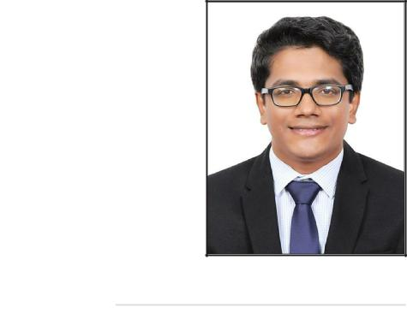

Digital Marketing

Google Adwords, Mailchimp, Google Analytics, Advertising on Facebook, Followerwonk, SproutSocial, Trello, Brandwatch, Litmus, Hootsuite, Hubspot, Woorank, Wordpress

Organizational

Attention to detail, Coordination, Research, Meeting deadlines, Multi-tasking

Interpersonal

Accepts Responsibility, Supportive, Team Player, Problem Solving, Social

Softwares & Web Applications

Microsoft Word, Microsoft Excel, Microsoft PowerPoint, Microsoft Outlook, SPSS Statistics, Edge1 OOH ERP & CRM, Image & Video Editing Tools, File Converters, Wordpress

Languages

English - Fluent

Hindi - Intermediate

Malayalam - Native

Tamil - Beginner

Areas of Interest

Advertising

Branding

Digital Media

Public Relation

Social Networking

To internally interface with pre-sales technical team to ensure customer satisfaction.

Prepare and submit daily/weekly/monthly reports for the management.

Education

M.B.A | 2011 - 2013
Mahatma Gandhi University
Specialisation in Marketing
B.Com | 2008 - 2011

University of Kerala

Specialisation in Accounting & Cooperation

Certificates

Certified Digital Marketing Associate

SMstudy

Key Digital Marketing Specialisms and framework that helps the most effective marketing channels

Certified Internet Marketing Practititoner

EC-Council

Search Engine Advertising, Social Media Marketing, SEO, PPC, Mobile Marketing, Email Marketing, Affiliate Marketing, Podcast Advertising, Video Advertising

ESOL International Business English

University of Cambridge

Achieved Council of Europe Level B1 in Cambridge ESOL Level Certificate

Effective Communication and Public Speaking

REPSI

Public Speaking Training Course

Projects

E-Waste Management

Wayzone IT Solutions, Trivandrum - India

Collection of corporate e-waste from companies located in Trivandrum, Kerala& then sending it to waste management services dealers in 2014

Brand Awareness and Brand Perception

Jaihind TV , Trivandrum - India

Brand Awareness & Brand Perception of Jaihind TV malayalam channel among south Kerala viewers in 2013

Organization Study

Syntax Soft India , Bangalore - India

A study on all the departments of the organization

Activities & Events

Crew Member for the event Football Fanfest conducted by Emirates Neon Group, Dubai Sports City 2016
Coordinator for the event Arabian Bubble Show conducted by ENG, World Trade Centre Dubai 2016
Marketing Team Member for the event Global Education Interact - Shaping lives and Careers, Cochin, India 2015
Student Member of TRAMA for the year 2011

Personal Profile

Date of birth - 11.10.1989

Gender - Male

Nationality - Indian

Marital Status - Single

Home Address - Kerala, India

Visa Status - Visit Visa

