Waiter/food runner/cleaner Curriculum vitae
TWO YEARS OF UAE EXPERIENCE
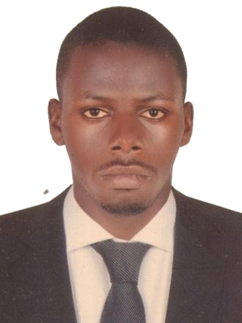Name:- Matsiko Emmanuel Nationality:- Ugandan
Visa status:- Visit visa
Email:-matsiko.378567@2freemail.com

C/o-Mobile No:-+971503718643

Personal profile

Am an outgoing and cheerful Waiter with more experience in customer service. I am very polite and respectful person. I know a lot about food and I can make recommendations as well as being allergy aware.
- Smart and neat
- Innovative and creative
- Self driven
- Open minded
- Highly organized

- Multitasking

Career objective

I would like to work with a well established restaurant or hotel that will fully utilize my experience and skills and I am willing to take up any job with good salary and benefits and am also willing to take up any additional training to enhance my knowledge and skills.
Employment history.
Awani restaurant JUMEIRA BEACH DUBAI(September -November 2014)- Kitchen cleaner, dishwasher.
I would clean up the kitchen floor, operate the dishwashing machine, organize all kitchen equipment in their respective areas, help kitchen staff and throw garbage.
Bahria restaurant,Catch 22 JUMEIRA BEACH DUBAI(November to date)- Dining cleaner, toilet cleaner, food runner, Waiter.
As a cleaner I would sweep and mop the restaurant dining area, clean and disinfect dining tables, help in setting up the tables, open umbrellas , clean and disinfect the toilet, clean the restaurant windows. As a food runner I would carry the ordered food from the kitchen to the food servers in the dining , make sure that all what the guests ordered for are all served by following up the order list, carrying the used plates and cutlery back to the dishwashing area. As a waiter I make sure that my allocated area is well set and clean to the required standards as I wait for the customers, I welcome the guests with a smile and usher them to their table, I present the menus to them, I give more information about the special food and drinks we have and offer recommendations if possible, I take their order for food and drinks and re-read it to them and then I offer their order to the kitchen and bar respectively and wait for the servers to serve the ordered food and drinks to the customers.

Career achievements
- Have gained great stamina to stand and work for long hours
- Have gained team-work skills
- Have improved on my communication skills
- Have gained knowledge about cleaning and disinfecting chemicals that their usage
- Have improved on my customer care experience
- Have gained and improved on my supervisory skills
- Have learned how to control my emotions
- Have gained experience to work with multiracial people
- Have gained more creativity and innovation skills
- Have gained experience to work under pressure
Qualifications
- High school certificate

- Food safety and hygiene certificate

Skills

- Excellent English both written and verbal
- Computer skills MS word Hobbies
- Making new friends
- Watching movies References
Available upon request

