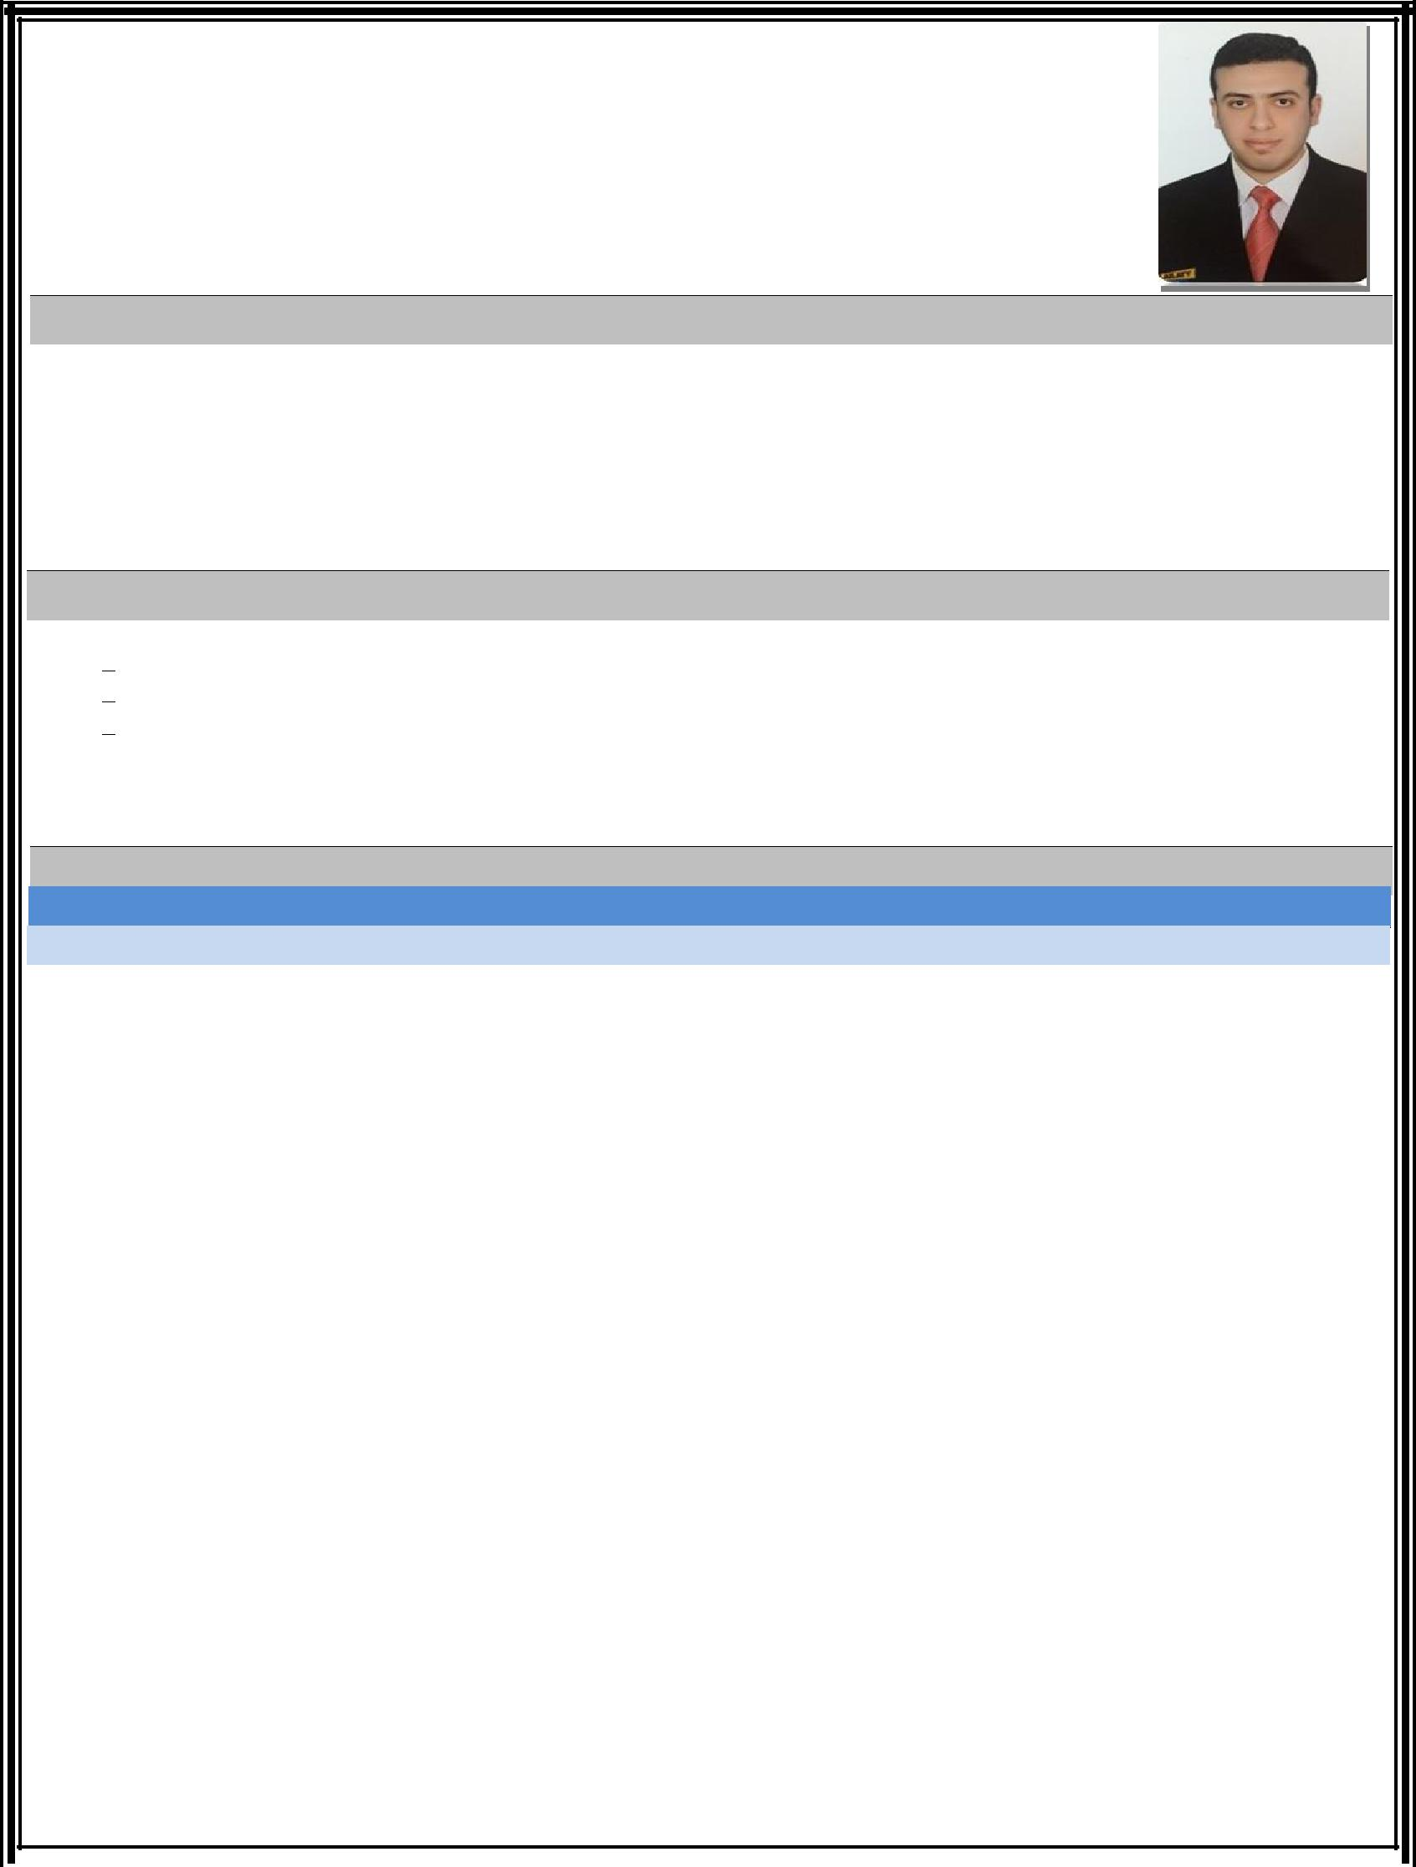
Gaber
Accountant

E-mail: gaber.378588@2freemail.com

- C/o 971504973598

BIO

Highly-accomplished, hard-working with experience in creating financial statements and annual budgets, as well as managing various tasks related to everyday financial activities. Possess fine-tuned problem-solving skills, developed through experience and knowledge. Qualifications include Proven interpersonal and commu-nication skills, to maintain professionalism at the workplace. Computer proficiency includes Microsoft Office and computerized accounting software.

QUALIFICATIONS

Annual statements – Analyze financial data and prepare reports/statements.
Hands-on knowledge of related automated financial and accounting software systems.

Proficient in MS Office (Excel in particular).

Analytical thinking, planning, organizing, prioritizing and executing with pinpoint accura-cy.
Problem analysis – Use judgment to solve problems efficiently.

WORK EXPERIENCE

Accounting:

United Group Enterprises for Marine & Petroleum Services.

May 2017 – February 2018
Finance and Administration Duties

- Responsible for accounts payable, get approvals to pay on a specified time.

- Responsible about general expenses review and analysis.

- Responsible about bank accounts (including: letter of guarantees, bank drafts, and bank trans-fers).

- Responsible about accounts receivable, follow up collection dates.

- Responsible about payroll taxes, add & deduction taxes, value add taxes.

Monthly / annually End Processing Responsibilities

- Assist with month-end process (including: Prepayments, Fixed asset depreciation, Accruals, Revenue recognition/reconciliation, Month-end adjustments and others tasks as required).

- Assist with month-end reconciliations of income statement & monthly financial position.

- Assist with preparation of monthly management accounts and quarterly reporting - financial analysis.

- Assist with preparation of yearly reporting (income statement - balance sheet - cash flow statement - equity statement – disclosures).

Internal/External Reporting Responsibilities

- Preparation of monthly and yearly according to Egyptian accounting standards.

- Assist with statutory and annual reporting

  - Assist with year-end audit

- Other reporting as required

Great Foods co. – Alexandria, Egypt.

Jan 2014 – April 2017
Accountant

- Post and process journal entries to ensure all business transactions are record-ed.

- Update accounts receivable and issue invoices.

- Update accounts payable and perform reconciliations.

- Prepare and submit weekly/monthly reports.

- Assist in the processing of balance sheets, income statements and other financial statements according to legal and company accounting and fi-nancial guidelines.

- Update financial data in databases to ensure that information will be ac-curate and immediately available when needed.

Accounting office – Alexandria, Egypt.

May 2013– Nov 2013 (6 months)
Junior Accountant at accounting office for 6 months

Great Foods co. – Alexandria, Egypt.

June 2010 – Dec 2011

Junior Accountant

- Post and process journal entries to ensure all business transactions are record-ed.

- Update accounts receivable and issue invoices.

- Update accounts payable and perform reconciliations.

Great Foods co. – Alexandria, Egypt.

Jun 2009 – May 2010

Sales representative.

EDUCATION

Bachelor of Commerce in Accounting.

Alexandria University, Alexandria, Egypt.

(2007 - 2011)

Online Education:

Swiss E-Learning Institute

- Business English Course.

LANGUAGES

- English, Professional working proficiency.

- Arabic: Native – Classical and Colloquial.

- Spanish: Beginner (Reading).

CERTIFICATIONS

- Advanced Level in General English and Conversation from ASEB Academy, Alexandria.

- Preparation of final account, balance sheet and construction accounting from Guide for Training & Consulting

- Communication and Presentation Skills from Alexandria University.

- Mini Office Diploma from AXON Academy, Alexandria.

- Leadership Camps Sponsored by (Qi Group).

TECHNICAL SKILL

Using internet applications.

Using Microsoft office and operation

system windows.

Work under pressure & self-

motivated.
Communicate well and handling customers.

Support Customers by providing best level of care for products and services.

Skills & Experience

Finance or accounting background
Excellent oral and written communications skills

Strong working knowledge of MS Office, excellent excel skills and confident with database use

Excellent time management skills and the ability to work to deadlines

The ability to work autonomously

Highly organized, with attention to detail and a pro-active thinker

Personable, enthusiastic, flexible, confident and friendly

Someone who takes ownership of their role and work will succeed in this corporate culture

Conferences & Events

Participated and Contributed to the Success of V.Malaysia 2016, This Conference with (Qi Group) and Sponsored by V.Foundation in Penang, Malaysia.

