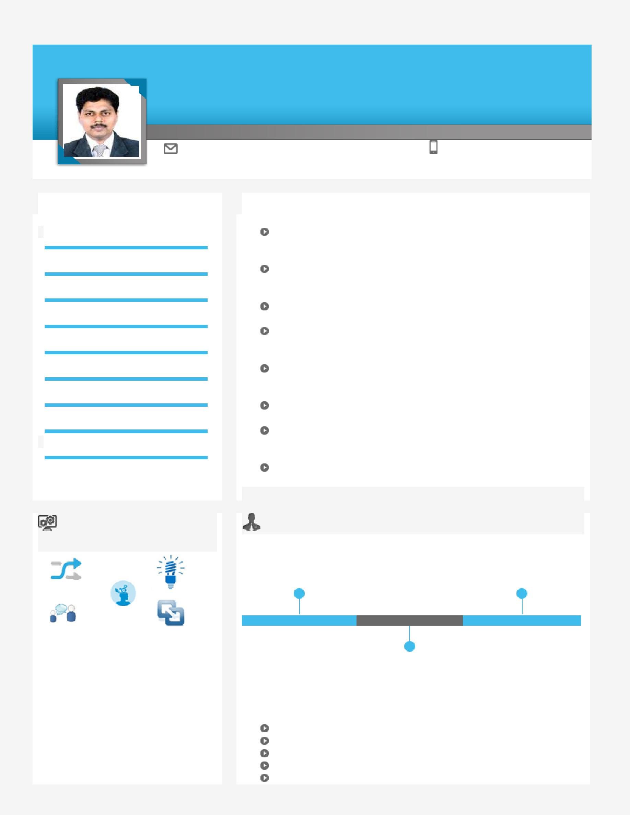
RAJA

A versatile, high-energy professional with the merit of executing prestigious projects of large magnitude within strict time schedules, cost & quality.

Project Execution Construction Operations Site Operations

Raja.378595@2freemail.com +971501685421

Key Skills

Project Execution

Resource Management

Construction Operations

Site Operations

Technical Support

Quality & Safety Operations

Cost Optimization

Commercial Operations

Team Building & Leadership

Profile Summary

A competent professional with 20 years of experience in Project Execution, Construction Operations and Quality & Safety Operations

Excellence in managing project operations involving feasibility studies, enquiry generation, techno-commercial discussion, machine, material selection, plant layout and so on

Experienced in managing construction operations as well as contract management activities

Proficient in inspecting field sites to observe and evaluating site conditions/feasibility for construction & availability of resources or facilities to collect field data & measurements

Skilled in ensuring compliance with various quality & safety maintenance guidelines at all stages to achieve cost reduction, waste reduction and ensure better project management Competent with the usage of various technologies like AutoCAD, 3D Studio Max, Photoshop and LisCAD

Expertise in constructing high rise buildings; successfully
worked with various clients like Hasabi Real Estate, Damac

Properties Co. LLC, Aecom, Al Batha Real Estate and so on
A result-oriented individual with strong analytical, communication,

interpersonal and organizational skills

Soft Skills |  | Career Timeline

 |  | Skylark Builders as | Engineering Consortium
 |  |  | Consulting Engineers as
 |  | Site Engineer
 |  |  | Civil Engineer/Inspector

Communicator | Innovator
 | Thinker
 | 1996-2005 | 2005- 2015 | Since 2015
Collaborator | Intuitive
 |  | Sun Engineering &
 |  | Contracting Co. L.L.C
 |  | as Civil Engineer

Education
Civil Engineering Diploma
Diploma in AutoCAD
Diploma in 3D Studio Max

Diploma in Total Station Survey

Diploma in Photoshop

Work Experience
Since Apr’15 with Engineering Consortium Consulting Engineers, Dubai as Civil Engineer/Inspector Key Result Areas:

Facilitating various activities including review specification, site supervision, construction operations as well as quality and safety operations
Contributing in submitting periodical report & slab approval to the Dubai Municipality Portal
Witnessing concrete plant trail mix test, third party lab concrete compressive test, site concrete test so on

Managing site inspection requests (IR) raised by the Contractor; taking appropriate actions, for the mockup inspections, material inspections, reviewing material samples and site installation inspections

Extending support in conducting daily site walk; issuing site observation reports / NCR for the non-conformities if any Identifying technical issues on site and resolving the same while coordinating with RE & Contractor Engineers

Performing preliminary review of prequalification documents, technical submittal, material submittal, method of statements, third party lab test reports, inspection test plan (ITP) and check lists

Conducting preliminary review of shop drawings, coordination drawings and as built drawings against contract drawings, revised drawings for authority submission, etc. as per specifications, local codes, statutory requirements and international best practice

Coordinating with clients, contractors & sub-contractors for ensuring smooth project execution
Extending support in ensuring adherence standards of performance, quality, cost and safety
Contributing in reviewing RFI and facilitating technical submittals

Monitoring quality of works & assessing site progress as per the quality of work progress
Updating progress markup plan for site progress; monitoring inspection progress of the project and preparing

weekly / monthly reports with progress photos and reporting to the Resident Engineer Analyzing contractors ITP’s and quality plan with respect to discipline related works

Managing various activities like issuing site observations, field instructions as and NCR upon discussing with the RE/PM Contributing in verifying the payment applications against site progress of work

Facilitating systematic execution of work; comparing with cash flow chart, S-curve, manpower histogram and coordinating with the contractor & various responsible agencies to complete their contractual obligation on timely basis Maintaining records for daily activities on site including progress photos

Significant Accomplishments:

Successfully managed key projects like Al Garhoud Mixed–Use Development, Akoya Oxygen ,Bugatti Managed key clients like Aecom, Damac, Emmar Properties and Al Batha Real Estate

Oct’05 – Mar’15 with Sun Engineering & Contracting Co. L.L.C., Dubai as Civil Engineer Key Result Areas:

Administered a team of Engineers & Supervisors; monitored execution of projects while reviewing architectural and structural drawings

Managed various activities like preparing shop drawings; reviewing specification, tender drawings, claims, contract conditions while facilitating the project staff

Liaised with Consultant & Structural Engineer various Service Consultants to ensure smooth execution of project Coordinated the works to ensure successful hand-over of the project

Previous Experience

May’96- Oct’05 with Skylark Builders, Kerala as Site Engineer (Contracting)

IT Skills

Proficient in MS-Office, LisCAD, Chief Architect and Internet Applications

Personal Details
Date of Birth: | 16th September 1975
Languages Known: | English, Hindi, Malayalam & Tamil
Industry Preference: | Consultancy/Contracting
Location Preference: | Dubai, United Arab Emirates
Visa Status: | Employment Visa
Nationality: | Indian
Driving License Detail: | UAE Light Vehicle Driving License & possesses own car

ANNEXURE

Projects Handled:

Engineering Consortium Consulting Engineers

Title: | Al Garhoud Mixed–Use Development Project ( 3B+G+M+8+RF,Hotel project for ACCOR GROUP-
 | 3Star Hotel IBYS, 4Star Hotel Mercure Hotel and Service Apartment), Garhoud , Dubai, UAE
Client: | Hasabi Real Estate
PMC: | AECOM
Operator: | ACCOR
Consultant: | Engineering Consortium consulting Engineers
Contractor: | HLG-Habtoor Leighton Group
Project Cost: | 400 Million
Title: | 216 G+1+R Villas at Akoya Oxygen Amazonia Cluster-P1, Phase-3, Dubai, U.A.E.
Client: | Front Line Investment Management Co.(Damac)
Consultant: | Engineering Consortium Consulting Engineers
Contractor: | Simplex Infrastructures Ltd.
Title: | Bugatti Villa
Client: | Front Line Investment Management Co.(Damac)
Consultant: | Engineering Consortium Consulting Engineers
Title: | Wild Flower 33 (nos.) G+1 Villas at Jumeirah Golf Estates, Dubai, UAE
Client: | Damac Properties Co. LLC
Consultant: | Engineering Consortium Consulting Engineers
Contractor: | Al Rakha General Contracting
Title: | 2B+Ground+7 Floors+Roof Serviced Hotel Apartment
Client: | Damac Properties Co. LLC
Consultant: | Engineering Consortium Consulting Engineers
Contractor: | Civilco Civil Engineering & Contracting Co.
Sun Engineering & Contracting Co. L.L.C.
Title: | 3B + G + 2P + 14 Typical Commercial & Office Building at Al Barsha, Dubai, U.A.E
Client: | Mr. Nabeel Dawood Murad
Project Cost: | 88 Million
Title: | G + 58 + HP Typical Residential Building & G+10P at Sheikh Sayed Road, Dubai
Client: | Sheikh Mohammad Rashid Al Makthum
Project Cost: | 250 Million
Title: | 3B+G+6P+44+HC Residential tower at Al Khan, Sharjah
Client: | Al Batha Real Estate
Project Cost: | 225 Million
Title: | 5.G+4P+HC+MF+42 Typ. Residential building at Al Khan,Sharjah,
Client: | H.H Sheikha Fatima Bint Mubarak
Project Cost: | 210 Million
Title: | B+G+13Typ+HC+SP Commercial & Residential Building on Media City, Dubai
Client: | Eng. Adnan Safarini
Project Cost: | 55 Million
Title: | 2B+G+15 Residential Tower at Dubai Marina
Client: | Emmar Properties
Project Cost: | 50 Million

 |  | Title: | G+1 Villa at Al Barsha 3rd Dubai
 |  | Client: | Mr.Khalil Rashed Ali Al Sulaity
 |  | Project Cost: | 1.1 Million
 |  | Title: | 2Building 4B+GP+12+Swimming Pool +GYM Residential Building at Culture Village, Dubai
 |  | Client: | RGM Limited
 |  | Title: | DOLCE VITA 1B+G+24 Floor + H.Club+Roof Residential Tower at Dubai Marina
 |  | Client: | Bella Vida Limited
 |  | Title: | Capital Bay 2B+G+2P+3rd (H.C)+16th Tower A+15th Tower B at Business Bay Dubai
 |  | Client: | DAMAC Star Properties
 |  | Title: | Executive Bay 3B+G+3P+15th &17 at Business Bay Dubai
 |  | Client: | DAMAC Star Properties
 |  | Title: | KBZF Wedding Hall at AL Fujairah, UAE
 |  | Client: | Sheikh Khalifa Bin Zayed Al Nahyan Foundation
 |  | Title: | Burjside Blvd. Tower B+GF+3 Podium+43 Floors at Burj Khalifa District Dubai
 |  | Client: | DAMAC Star Properties
 |  | Title: | KBZF Wedding Hall Al Bougha -Sector 9 at Umm Al Quwain, UAE
 |  | Client: | Sheikh Khalifa Bin Zayed Al Nahyan Foundation
 |  | Title: | Al Jubail Market, Sharjah, UAE
 |  | Client: | Government of Sharjah Directorate of Public Works
 |  | Title: | KBZF Wedding Hall Al Rafaah, Ras Al Khaima, UAE
 |  | Client: | Sheikh Khalifa Bin Zayed Al Nahyan Foundation
 |  | Title: | B+G+5 Floors, Dubai Industrial City -1, UAE
 |  | Client: | Dubai Industrial City

