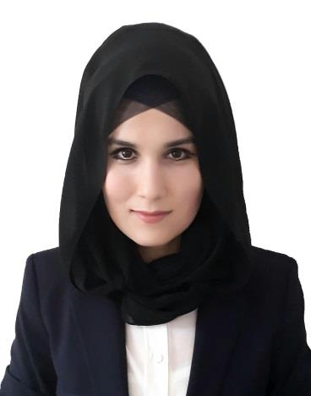
C/o-T: +971506425478
E: navruz.378602@2freemail.com
Visa status: Visit visa - extendable

Navruz
FASHION RETAIL ASSISTANT

^{Summary}
A confident, energetic retail assistant who is passionate about fashion and excited by this challenging fast paced environment. Able to take initiative and plan efficiently without having to take direction at all times, and working in a fashion retail store.
 | Now looking for an opportunity to work for a company who truly value their staff and will strive to develop their career to the next stage.
Skills | Fashion  Styling  Art & Design  Merchandizing  Brand knowledge  Creative thinking  Fashion drawing  Pattern making  Stitching | Retail  Customer service skills  Up selling  IT literate  Marketing & promotions  Deadline orientated  Great sense of style  Stockroom procedures  Attention to detail | Personal  Sociable personality  Team player  Self-motivated  Creative  Responsible  Dedicated  Flexible  Loyalty
Career | RETAIL ASSISTANT “ Madina ” Boutique March 2014–Aug 2017  Fashion Retailer  Working as part of an enthusiastic team within a commercial, sales driven and fast paced fashion retail environment. Responsible for driving sales, ensuring good customer service, building relationships and ensuring the smooth running of the shop floor.  - Actively greeting customers and maintaining a level of conversation during their store visit.  - Taking actions to improve the branch performance.  - Dealing with all customer complaints in a professional and courteous manner.  - Maintaining superb visual standards within the store.  - Promoting specific lines under the guidance of management.  - Unpacking and checking all new stock deliveries.
Academic | Tashkent Islamic University 2003 – 2008  (Faculty history and philosophy of Islam)
Languages | Arabic – Working level  English – Working level  Russian – Mother language  Persian – Working level

Computer Skills
Microsoft Office – Working Level (Excel and Word)
Point of Sales (POS - Navision)

Hobbies Read books
Ping Pong

