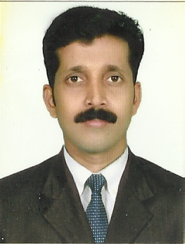

SAJITHAN

C/o-Mobile # +971501685421
Email ID: sajithan.378615@2freemail.com

Application for the post of “Snr.Carpenter”

Objective To utilize my skills towards a challenging carrier in a growth oriented and leading
Organization that recognizes and values individual contribution and which will provide opportunities for continuing growth and advancement

Experience: (1) Peak Builders & furniture (kannur) from 1998 to 2010. Working as a Carpenter.

- Verify the production list.
- Check the quality of material.
- Inspect The Non conforming material.
- Coordinate with Production Section to eliminate non conformity sources.

(2) Worked as Carpenter in Al Jaber Carpentry & Decor. From 2011 to still in U.A.E.
- Supervising all jobs in assembly shop.
- Checking the incoming material from suppliers.
- Assembling the material as per drawing.
- Controlling the work hours.

Education: Pre Degree, Finished 6 months interior course in kannur (Brush man school of arts)

Hobbies : Very much interested in business & communicating with people at good manner.

Computer skills: Web browsing.

Personal Details:
Date of Birth : 11/03/1977
Nationality : Indian
Marital Status : Single
Visa Status : Employment

Passport Details
Place of Issue : Kozhikode
Date of Issue : 11/09/2003
Date of Expiry : 11/09/2013

Languages Known : English, Hindi, Urdu, and Tamil & Malayalam.

In view of the above, I request you to consider my case for employment in your esteemed organization and assure you that I will perform duties to the entire satisfaction of my superiors, I will put in my best of efforts for the all round process of the organization.

