CURRICULUM VITAE
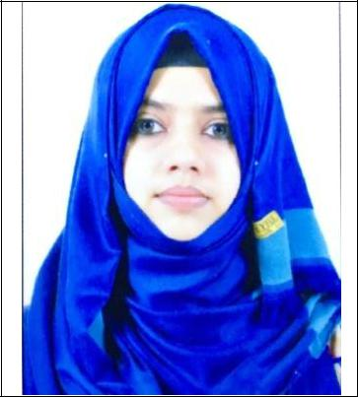

Dr. LEMIZ K

E-mail: lemiz.378644@2freemail.com

MOBILE No: C/o 0501685421

ADRESS: - ABUDHABI

POSITION APPILIED: -CERTIFIED PROFESSIONAL CODER

Career Objective

Want to work as an advancing medical coding professional in a challenging and intriguing working atmosphere with the utilization of adept coding expertise and proficiencies.

Key Skills

- Informative in different areas like Anatomy & Physiology, Psychology, Advanced Medical Terminology, and other related medical sectors

- Possesses knowledge of quality related to medical coding methods and guidelines, including ICD-10, HCPCS, and CPT.

- Submission and resubmission of insurance claims as per the provided data.

- Submission and resubmission of insurance claims as per the provided data.

- Competent at reviewing records for completeness, correctness and compliance with regulations.

- Understand insurance guidelines including Government authorities and Private insurance companies.
- Able to use document scanning management software.
- Talented in assuring accuracy of medical records in compliance with state and federal regulations.

- Familiar with coding and resubmission systems of hospital in Abudhabi.

Educational Qualifications

- Professional Medical Coding from Cigma Academy under AAPC

- BACHELOR'S DEGREE IN HOMEOPATHIC MEDICINE MARTIN HOMOEOPATHY MEDICAL COLLEGE

Dr.MGRUniversity, TAMILNADU From Sep 2010 toNov 2016

- Higher Secondary Education From State Board of Kerala

Professional Qualifications

- Certified Professional Coder (CPC) Certification from American Academy of Professional Coders (ID:01536126)

- Doctor in Homeopathic Medicine

Working experience

- Working as a medical coder in Universal Hospital Abudhabi from 1st June 2017 to till date.

- Worked as a homoeopath in Kerala for one and half years.

Duties and Responsibilities

- Ensuring accurate coding and sequencing diagnosis and procedure codes as specified by established by coding principles and guidelines of UAE health department.

- Assigning medical codes using ICD-9, ICD-10, CPT and HCPCS codes.

- Operate data base and medical coding software like RHIS,INSTA,GREENRAIN and CARE EMR.

- Ensure claims are entered and submitted on time.

- Process a minimum of 200 OP coding and more or less 40 documentation a day conforming to icd-9, icd-10 and CPT.

- Reviewing and analyzing patient medical records to ensure all applicable Patient data is assigning the relevant codes.

- Contacting clinic or other departments for collecting the additional information to complete coding process.

- Answer the enquiries from Doctors, Patients and Insurance companies.

- Evaluate and re-file appeals of patient claims that were denied.

- Attending seminars, workshops, and publication to update the latest changes in insurance industry and coding rules.

Computer skills

- MS OFFICE ( Excell, word and Power point)

- Windows -10, windows-8, vista, XP.

- Typing speed is 100WPM.

Personal Details
Marital Condition: | Married
Sex: | Female
Citizenship: | Indian
Date of Birth: | 15-oct-1991
Visa: | Husband visa

- I want to prove myself everywhere and every moment as a new challenge.

Declaration

The information furnished above is correct to the best of my knowledge.

Dr.LEMIZ

