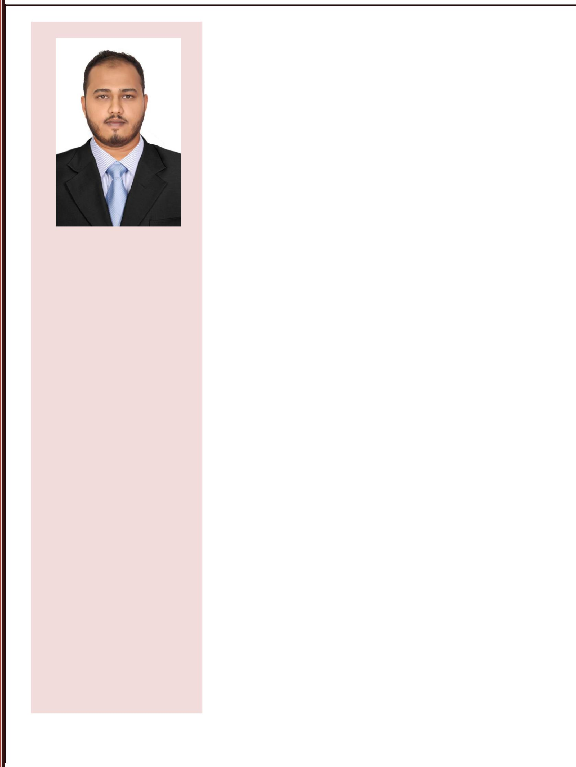

Expert in:

Perform Testing Pipe Measures Piping Components Piping Fittings Safety Measures Disciplinary Action

EDUCATION

Process Piping Engineering. Diploma in Mechanical Engineering from DTE,

Bangalore.

PUC(PCMB) from

Department of Pre-University

Education, Karnataka

LANGUAGES

English, Hindi, Malayalam, Kannada, Tamil, Urdu.

IMDAD

Mobile: C/o 0501685421 email: imdad.378662@2freemail.com

ABOUT ME

I am a Mechanical QC Engineer (with 2 Years Experience) seeking a full-time position in the field of Quality control Engineering, where I can apply my knowledge and skills for continuous improvement.

Career Profile

EXPERTISE CONTRACTING COMPANY LTD.

Expertise is one of the leading Contracting Company in Jubail Kingdom of Saudi Arabia

www.expertindus.com

Role: QC Engineer- January 2017 – June 2017

Major Achievements

Worked under 4 different Shut down Projects.

Worked under sabic affiliated companies like Jubail United Petrochemical Company, Petrokemya Petrochemical Company, kemya Petrochemical company and Ma’aden Phosphate Company.

Managed a team of 20 Employees.

Played a key role in Inspection.

Completed Work within a given time.

Had Given a seminar for QC Engineers(trainee).

PETROCON ENGINEERS AND CONSULTANTS

Petrocon is one of the leading Oil & Gas, Power, Food and

Utility Sectors in the India

www.petroconengineers.com

Role: Site Engineer – July 2015 – July 2016

Major Achievements

Instructing Site foreman for Utility, Distillation, Epoxy and effluent treatment plant (ETP) taken care of all pipe supports and piping installation.

Lead and coordinate with the QA/QC team in all quantity related aspects.

Preservation of mechanical equipment such as Main engine, Air compressor, Centrifugal pumps.

Interacting with Designers for queries related to design and explaining the same to site people.

Piping study for high point vent low point drain.

Page 1 of 3

PERSONAL SKILLS

Flexible, Honest and

Hardworking

Capable to do things

independently

Quick learner

Ability to do multitask and

manage conflicting demands

Good work ethics

Excellent communication and influencing skills.

Excellent time management skills & can meet the deadlines

without compromising on quality.

COMPUTER SKILLS

AutoCAD 2D, Creo, Primavera(PPM),PDMS, Microsoft Word and Excel

PERSONAL

INFORMATION

Address: Dubai United Arab Emirates

Date of Birth: 24 May 1993

Nationality: Indian

Marital Status : Single

Visa Status: Tourist Visa (Valid

Till 8 June 2018 )

HOBBIES

Cricket, Martial Arts, Riding.

Maintaining all preservation documentation

Duties and Responsibilities

Perform all daily inspection and test of the scope and character necessary to achieve the quality of construction required in the drawings and specifications for all works under the contract performed ON or OFF site.1

Cary out inspection and checking for all quality related procedures in the site and ensures activity at the site are as per approved method statement and inspection test plan.
Coordinate with the consultant’s representative and Site En-charge for inspection and meeting about quality problems including the closure of Non-Compliance Report.1

Report to the QA/QC Manager, control, and monitor all activities related to Quality Management System, QMS.1

Taking care of QA/QC documents of the entire project including certificates, calibration, test results, inspection requests, non-compliance r1eports and site instruction/observations, permanent materials delivered and other QA/QC documents. Responsible for the closure of Non-conformance, NCR and Site Instruction, SI.

Responsible for the quality and workmanship of every activity, thorough knowledge of all phases of engineering construction relating to Civil, Architectural and Structural discipline interfacing the multidisciplinary operations.

Develop method statement for the activity including risk assessment and job safety environmental analysis and Inspection Test Plan and Checklist based on specifications of the project.

Carry out Internal Audit at the site as scheduled in the Project Quality Plan, PQP.

Liaise the Technical Engineer for submission of material submittals to Consultant.

Training And Certification

Trained in PROCESS PIPING ENGINEERING as per ASME B 31.3 with knowledge on the following

Pipe sizes, Schedule No.
Codes and Standards.
Familiar with Piping Components, Fittings
Process Flow Diagrams, Utility Flow Diagrams, Piping and
Instrumentation diagrams
HAZOP study
Development of Plot Plan
Development of Piping Layout, Equipment Layout

Page 2 of 3

REFERENCES Non Destructive Testing (NDT)

Available on request | Trained to perform testing using the conventional NDT methods which
 | include RT, UT, MT&PT on applications such as Pipeline, Piping,
 | vessels, Structural and raw material inspections
 | Familiar with Standards & Codes like ASME V, API 1104, AWS D
 | 1.1, ISO & BS.
 | LEVEL-II RT - ASNT SNT-TC-1A
 | LEVEL-II UT - ASNT SNT-TC-1A
 | LEVEL-II MT -ASNT SNT-TC-1A
 | LEVEL-II PT - ASNT SNT-TC-1A
 | DECLARATION
 | I hereby declare that all the above given facts are true to the best of
 | my knowledge and belief. If I get this opportunity, I assure that I
 | will work sincerely to meet your expectation.
 | Imdad
 | Place: Dubai

Page 3 of 3

