Curriculum Vitae
PARKAR
E-mail : parkar.378665@2freemail.com
C/o-Mobile no : +971502360357
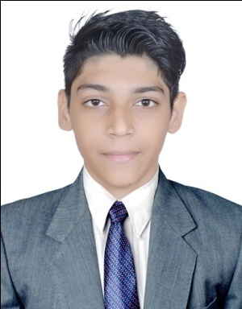

-----------------------------------------------------------------------------------------------------------------------

ABILITY: Intend to build my career with growing company with honest, committed & dedicated people in positive work environment which will help me to explore myself fully and realize my potential. Willing to work as key player in challenging and creative environment.

----------------------------------------------------------------------------------------------------------------------

WORK EXPERIENCE:

- Worked in Accenture as a Content Moderator Since Sept 2016 – Feb 2017
- Worked in Bit win Computers as a Hardware & Network Technician Since Mar 2017 - Feb 2018.

----------------------------------------------------------------------------------------------------------------------

Academic Qualifications:

- SSC ( Class 10th) March 2010 Passed
- HSC ( Class 12th) February 2012 Passed
- B.Sc (Information Technology) April 2016 Passed
----------------------------------------------------------------------------------------------------------------------

Other Qualifications:

- Certificate in Hardware Engineering from NIITAPS, Maharashtra, 2014.
- Certificate in Linux Fundamentals from NIITAPS, Maharashtra, 2014.
- Certificate in Network Engineering from NIITAPS, Maharashtra, 2014.
- Certificate in CCNA from RST Forum, Maharashtra, 2016.

----------------------------------------------------------------------------------------------------------------------

Technical Knowledge Preview;

- ​Applications​ ​: ​Microsoft (Word, PowerPoint, Excel, Access, MS
Outlook), Adobe Photoshop, Dreamweaver, Smart

Draw Visual Studio, VMware Workstation, and Linux.
- ​ Programming Languages:​ ​C, C++, Java, HTML, Oracle Databases, and Asp.net.

----------------------------------------------------------------------------------------------------------------------

Passport Details:

- Passport Issued Date : 29th April 2016

- Passport Expiry Date : 28th April 2026

- Passport Issue Place : Mumbai, India

----------------------------------------------------------------------------------------------------------------------

Personal Data:

- Date of Birth : 29th Sept. 1994

- Nationality : Indian

- Languages Spoken : Hindi, English and Marathi

- Marital Status : Unmarried

- Religion : Muslim

- Gender : Male

----------------------------------------------------------------------------------------------------------------------

Declaration: I hereby certify that the information and facts written above are true to the best of knowledge and belief.

----------------------------------------------------------------------------------------------------------------------

