Dr.Huda

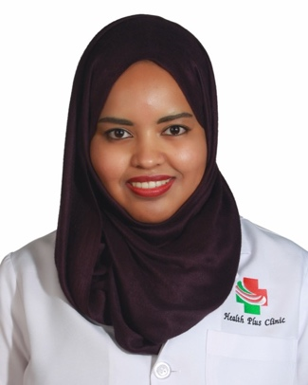
Place of Birth: Sudan – Khartoum Date of Birth: Jan,1986
Nationality: Sudanese
Gender: Female
Marital Status: Single
Religion: Muslim
Languages: Fluent in Arabic and English Mobile : C/o 0501685421
E-mail: huda.378686@2freemail.com

CAREER OBJECTIVE

Seeking a challenging career in a growing organization, where my professional skills and experiences are utilized.

MANAGEMENT & LEADERSHIP SKILLS
- Taking the initiative & responding flexibility to change situation.
- Accepting responsibility for mistake & wrong decisions. Goals setting, and shared vision; Making logical decision; Display high integrity and honesty
- Solves problems, analyzes issues: Collaborates promotes teamwork. Open minded and straight forward

STRENGTHS:
- I encourage team work as well working in a pleasant and friendly atmosphere.
- As my experience in the medical services and dental private clinic everyone is valued as his own character by listening and working together with the management and the department supervisor towards the goal and vision of the facility.
- I’m patient person and I continuously develop myself and transform abstract onto con concrete; capable of working under pressure, calm in crises.

WORK EXPERIENCE:

Call Center Agent - Cupola CTS – Dubai Free Zone – 2011 - 2 Month
- Obtains client information by answering telephone calls.

- Establishes policies by entering client information.

Account Assistance – UNASCO LLC. – Dubai -3 Month
- Ensuring all payments amounts & records are accurate.
- Prepares reviews, reconciles, and processes various accounting documents.
- organized files and databases

- Preparing, presentations, reports, and memorandums
- Monitoring the operations.
- Serving as the liaison and go-to person for any office conflicts and inquiries
G.P Dentist – Health Family Clinic – 2015 – 2017

EDUCATION:
AUST Ajman University of Science &Technology- 2010
D.D.S Degree Faculty of Dentistry
Westford School of Management UK
Diploma Degree – Healthcare Management & leadership - 2017

