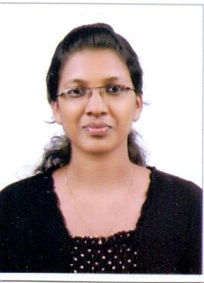
Surabhi

Biomedical Engineer

Ph. C/o 0501685421

Email id: surabhi.378700@2freemail.com

Passport Date of Expiry: 30/06/2026

Career Objective:

Looking forward to work in a career oriented environment, where I could project my innovative skills in the field of biomedical engineering with a high success rate, for the organization and for the self-growth.

Work Experience:

Duration | Name of the Post | Institution
01.02.2017 to | Biomedical Engineer | Panacea Hospital, Bangalore
28.02.2018
02.05.2016 to | Biomedical Engineer | Shri Sathya Sai Medical College & Research
27.01.2017 |  | Institute, Chennai
21.01.2016 to | Biomedical Engineer | PVS Hospital, Kerala
23.04.2016 | Trainee

Technical Skills:

- Maintenance and troubleshooting of biomedical equipments clinically as well as technically.

- Handling technical & operational activities of installing biomedical equipments.

- Provide training to new nursing staff on medical equipments installed.

- Maintain the documentation for biomedical equipments.

- Updating the inventory of all types of medical equipments installed in the hospital.

- Coordination with service personnel of various medical equipment companies.

- Follow up the Preventive maintenance schedule and calibration schedule for medical equipments.

- Meet with incharges of critical care department on daily basis.

Equipments Handled:

- Cath lab - Philips (Allura Xper)

- Ventilator – Maquet(servo-I, servo-s), Drager(Evita 2 Dura,Savina,Savina300), Taema (Horus)

- Anesthesia machine – Drager(Fabius, Fabius Plus), GE(ZY9100, 9100C)

- Monitors - L&T(Star 55,Planet 50), Drager(Vista 120,Infinity Vista, Infinity Vista XL), BPL(Smart)

- Syringe pump & Infusion pump - B-Braun(Infusomat, Perfusor Compact)

- X-Ray & C-Arm – Siemens(Multiphos 15R,Multimobile 5C,Multimobile 2.5), Philips(BV Libra)

- Ultrasound – Philips(HD11XE,Envisor-C)

- Dialysis – Fresenius (4008S, 4008C, 4008B), B-Braun (Dialog) etc.

Educational Qualification:

Exam/Degree | Year | Name of Institution, University | Percentage
B.Tech Biomedical | 2015 | Rajiv Gandhi College of Engineering & Technology | 8.98(C.G.P.A)
Plus Two | 2011 | Govt. G.H.S.S, Azhchavattom | 83%
SSLC | 2009 | Govt. Ganapat Model Girls Higher Secondary School | 82%

Computer Literacy:

MS Office (Word, Excel. PowerPoint), C & C++, Mat Lab

Interpersonal:

Self-Management, Verbal & Non-Verbal Communication, Problem Solving, Decision Maker, Quick Learner.

Personal Information:

AGE, DATE OF BIRTH | 24, 03/09/1993
NATIONALITY | Indian
LANGUAGES KNOWN | English, Hindi, Tamil, Malayalam, Kannada
MARITAL STATUS | Single

