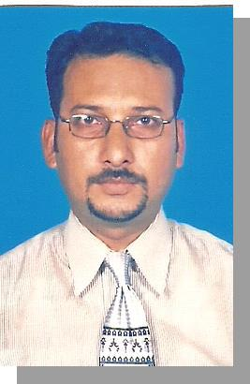
Anwar

Anwar.378710@2freemail.com

C/o-+971505891826

To be a part of a leading company in Event Management and Marketing, Sales Management and Client Services in which, I have gained considerable achievements and talents, eager to learn and grow new techniques and business in competitive market.

Personal Information
Father’s Name | : | M.A.Khalique Hashmi (Late)
Date of Birth | : | 18 May 1970
Place of Birth | : | Karachi-Pakistan
Religion | : | Islam
Res. Address | : | D-35, Rose Garden, Gulistan-e-Jauhar, Block # 13, Karachi.
Res. Tel. | : | +92-21-333-3877307

Skills & Abilities
- Proficiency in using Computer Application & Graphic Software; Windows, MS Office, Internet, Social Networking Software, Adobe Photoshop, Freehand, Coral Draw, In page etc.

- Good designing and creative capabilities using computer softwares and other mediums; wood, metal, plastics, glass, papers and display products.
- Having Managerial and activation capabilities especially in events and fabrications.

- Ability to work under pressure and a good learner.

- Good visionary capabilities.

- Speaks good English and interact with other nationalities easily.

Hobbies & Interests

- Traveling.
• Reading Books especially autobiographies, Management, Market ing & Skills.
- Watching movies and documentaries esp. National Geographic & Discovery.

- Learning different skills in designing and fabrication.

Education
Bachelors in Commerce (B.Com) in good second division from Govt. Islamia Arts & Commerce College (Karachi-Pakistan)

Experience Details

•

2009 – till date.

Client Service Manager:

Industry:

Adplus Marketing Services (Karachi)

Events Activation, Merchandising & Marketing

Duties: Coordinate/supervise events and BTL Activations, timely activation of the projects, manage all fabrication projects like Display Stalls, POS Displays and materials , printing materials, coordinate with the clients in theirs projects, and manage teams of the events and fabrication.

•

2003 to 2009.

Sr. Sales Officer:

Industry:

S. Ejazuddin & Co. (Karachi)

Medical & Surgical Products Marketing

Duties: Supervise/Co-ordinate Sales force, surveys of the markets, identifying

new customers, launchings of new products in the markets, closing sales deals and meeting sales targets, manage company events at different hospitals.

•

1999 to 2002. Marketing Executive Industry:

:

Aftab Surgical (Karachi)

Medical & Surgical Products Marketing

Duties: identifying new customers, achieving sales targets, conduct promotional activities at medical stores, hospitals, clinics and events, coordinates with the product principle.

Professional Achievements
- Manage and Activate Events and Products Branding Projects of some Media Cos. And Agencies as third party activation.

- Branding and Activation Experience in some of the Local and Multinational Products such as, Samsung, Energizer, Veet, Vital Tea, Swiss International Airlines, Arena Multimedia Institutes.

- Participated in Company visits and Marketing workshop in Singapore & Malaysia through S.Ejazuddin&Co.

- Participated in different workshops and seminars in Sales, Marketing and Events.

Reference will be furnished on request.

