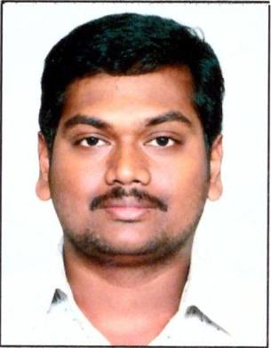
RESUME
RAVI
C/o-Mobile: +971501685421

ravi.378723@2freemail.com

I'm here on visiting visa to explore Dubai and find me a better opportunity to engage myself in the field of my interest (Civil Engineer, land surveyor, Site Engineer, Quality Control (Q.C), Quantity Estimation & Planning (Q.S), civil works Supervising)
Career Objective:
To work with an organization, which can provide excellent opportunities for continuous learning and development by which I can give the best of my abilities for the prosperity of the organization.
Technical Skills:
Programming Languages : C,C++.
Operating system : Windows.
Packages : MS –OFFICE.(EXCEL),AUTOCAD 2D, 3D, STAAD PRO….
Strengths:
- Assiduous in nature and Punctual.
- Updating all inveterate actions as per technical basis.
- Disciplined in all terms.
- Good communication skills.
- Hard working and can cope up in any conditions.
- Can grasp things fast
Project Name Analysis and Design of Residential Apartment Building:
This project helps in analyzing the whole structure by staad pro and designing by sp 16.a building in analyzed using space frame analysis and is designed using limit state method conforming to Indian standard code of practice

Experience:
Company : IVRCL
Project : All Civil Works
Period : 3 years
Skills in : marking, levelling, p.c.c work, R.c.c work, prepare labour report,
Estimation, quality control and planning qs.

Job Responsibilities:
- Preparation of MIS Reports
- Client &sub contractor billing
- Preparation of Deviation Statements
- Price variation Bills, Review presentations
- Monthly Budget Expenditure plans
- Finalizing Bought out items as per technical specifications
- Monitoring site
- Preparation of D.P.R and Monthly Reports
- Assisting seniors in day to day site execution activities
- Regular follow-up with the contractors and outside agencies for site execution.
- Co-ordination with various departments for smooth flow of work
- Monitoring work progress as per plan
- Overall site Management & Planning
- Preparation of Quantities
- Quality control of concrete works &all civil works
- Planning the daily project activity
- Quantity surveying of material.

Academic Qualifications:
- Pursuing masters degree in structures from Jawaharlal Nehru technological university -Kakinada
- Completed Graduation B.E –Civil from JNTU-K affiliated college
- Completed Intermediate with an aggregate of 74 %
- Completed SSC with an aggregate of 73 %

Personal Details:
Date of birth : 06-4-1992
Marital status : MALE
Nationality : Indian
Languages Known : TELUGU, ENGLISH, HINDI

Declaration:
I hereby declare that the above-mentioned information is correct up to my knowledge and I bear the responsibility for the correctness of the above-mentioned particulars.

