Curriculum Vitae

Hamza
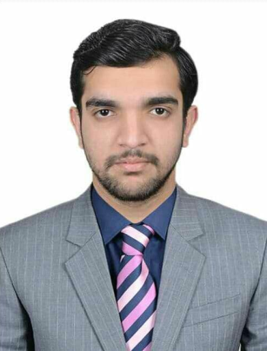
C/o- Cell #: +971-502360357
E mail: hamza.378739@2freemail.com

Objective:

To become a part of a highly skilled team of professionals. Try to groom the
organization with my abilities and skills.

Education:

2013-2014 D.Com. (Accounts)
Punjab Board of Technical Education Lahore.
2011-2012 Matric. (Computer Science)
Board of Intermediate and Secondary Education Gujranwala.

Experience:

- 1 Year Internship as Network Assistant with PAPTECH COLLEGE

Responsibility:

- installing and configuring computer networks and systems
- identifying and solving any problems that arise with computer networks and systems
- consulting with clients to specify system requirements and design solutions
- budgeting for equipment and assembly costs
- assembling new systems
- maintaining existing software and hardware and upgrading any that have become obsolete
- monitoring computer networks and systems to identify how performance can be improved
- working with IT support personnel
- providing network administration and support
Experience:

2 Year Working as Textile Designer as a Tracer at Madni Textile GRW.

Responsibility:

- producing sketches, designs and samples for presentation to customers
- making up sets of sample designs
- liaising with clients and technical, marketing and buying staff to plan and develop designs
- accurately interpreting and representing clients' ideas
- working out design formulae for a group of samples
- assessing and approving completed items and production standards
- working independently, if self-employed, or liaising closely with colleagues as part of a small team
- using specialist software and computer-aided design (CAD) programs to develop a range of designs
- experimenting with colour, fabric and texture
- maintaining up-to-date knowledge of new design and production techniques and textile technology
- developing new design concepts

Achievements:
- CCNA (Routing & Switching) Certified.
- CCNA (Routing & Switching) training holder from PAPTECH COLLEGE
Gujranwala.
- CCNP (Routing & Switching) training holder from PAPTECH COLLEGE Gujranwala.
- Certificate of honors BURHAN CHEEMA Pakistan.

Interest and hobbies:

- Cricket.
- Book reading.

Personal Traits:

Young, energetic and willing to work in any capacity under any authority.

Personal Profile:

Date of Birth July 20 , 1995
Religion Islam
Nationality Pakistani
District of Domicile Gujranwala, Punjab
Marital Status Single
Gender Male

References:

Reference can be provided on request.

