JAMSHEEN

Curriculum vitae
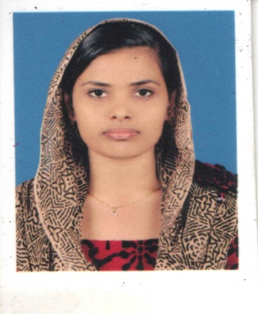  Email  Jamsheen.378818@2freemail.com  Personal Information  Gender: Female  Nationality: Indian  Marital Status: Married  Date of Birth: 09/01/1989  Contact: C/o 0505891826 | OBJECTIVE  Interested in a career that demands a combination of hard work and analytical skills. The job should offer avenues for rapid growth within its own scope, while opening new avenues for cross-functional top-level management in a long run. Intend to structure my growth in pace with the ever-changing corporate environment.  WORK EXPERIENCE  Working as Operation Care - Coordinator DM WIMS Medical College & Hospital in Meppadi, Wayanad from Jan 2013  Job Profile  - Attention to detail, customer focused, situational awareness, critical thinking, problem solving, reading comprehension, clear communication  - Attending to all customer related issues.  - Managing a staff strength of 80 in the field of customer care.  - Resolving all issues regarding customer service.  Work Experience  Period Organization Position held Station  2008-09 On AIR Airlines and Aviation Academy Kollam Event Management Beach Orchid  2010-12 Akbar Travels of India Pvt. Ltd Reservation Executive Calicut  2013-continuing DM WIMS Medical College Hospital Operation care Assistant now as care coordinator Wayanad  Worked as Reservation Staff in Akbar Travels of India Pvt. Ltd  (JAN 2010 to DEC 2012)  Job Profile  - Processes reservations by mail, telephone, telex, cable, fax or central reservation systems referral.  - Preparing of daily reports.  - Processes reservations from the sales office, other hotel departments, and travel agents.  - Prepares letters of confirmation  - Communicates reservation information to the front desk.  - Attending to customer complaints and enquiry.  - Processes cancellations and modifications and promptly relays this information to the front desk.  - Processes advance deposits on reservations.  Language Proficiency:  - To speak Malayalam, English, Tamil  - To write Malayalam, English, Hindi  - To read Malayalam, English, Hindi  Educational Qualification:  Course Institution Year Of passing Marks  MBA Hospital Administation Bharathiyar University Calicut PURSUING PURSUING  BBA Bharathiyar University Calicut 2010 60%  Diploma in Airline and Airport Management On Air Airlines and Aviation Academy Kollam 2009 85%  HSC KMO Hss Koduvally 2008 72%  SSLC(CBSE) Pleasant English School Omassery 2006 75%

I hereby declare that the information given above is true and correct to the best of my knowledge.
Place: Calicut Jamsheena
Date: 06.02.2018

