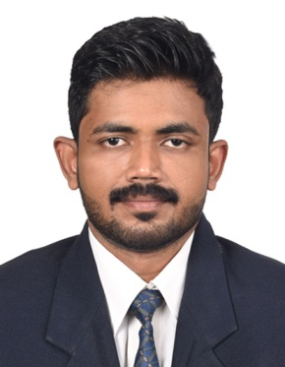
SIBIN
Accounts Assistant
Email: sibin.378861@2freemail.com
C/o-PH NO: +971504973598

JOB OBJECTIVE

To seek a challenging position as an Accountantin a progressive and reputedOrganization &eager to contribute a strong finance, accounting and administrative background to support the success of the organization.
Summary of Skills & Experience

- Hands on experience on Tally
- Basic Accounting knowledge
- MS Excel skills
- Written Communication Skills
PROFESSIONAL EXPERIENCE:

14 PEAKS EVENTS:
14 Peak Events, is one of India’s leading Event Management Company offering multi-disciplinary services across globe and has many corporate companies in its client base.
Accounts Assistant (August 2017-Till Date)
- Maintains Accounts payable records
- Prepare monthly close of the financial profits
- Assist in the preparation of annual financial reports
- In charge of all accounting functions
- Responsible for the financial transaction
- Responsible for the distribution of invoices
Interior Expressions:
Interior Expression is into manufacturing of architectural furniture’s, interior designing & decoration unit
Accounts Assistant. (July 2013 – July 2017)
- Performing accounts payable functions.
- Managing accounts and generating weekly checks for vendors.
- Assisted accountant for budgets, payrolls, forecasting, accounts payable and receivable.
- Manage company accounts and tax returns for audit.
- Ensured compliance accounting deadlines.
- Expertise in handling purchases and ledger reconciliation.
- Data Entry and Book-keeping functions.
- Issuance of Receipts and maintenance of cash on imprest basis.

EDUCATION

- Master of Business Administration in Finance Management From Bharathiar University-2016
- Bachelors of Commerce (Specialization in Computer Application) From Bharathiar University-2013
- Plus Two (Commerce) ACS EMHSS, Kaloor-2008
- 10thGrade ACS EMHSS, Kaloor-2006

TECHNICAL SKILLS

- MS Office
- MS Excel
- Tally
STRENGTH
- Positive attitude, team player and communication skills.
- Adapts quickly and positively to changing environment.
- Hard working, analytical approach and multitasking.
- Attention to detail.
- Streamlining workflow and creating a spirit of team work environment to enhance profitability.

OTHER ACCOMPLISHMENTS

- Participated in numerous sports events in School and District levels
- Participated in School art fest in District level.

PERSONAL INFORMATION

Nationality : Indian
Age & Date of Birth : 28, 11th April 1989
Languages known : English, Hindi, Malayalam
Marital Status : Single

DECLARATION:I hereby declare that all the above statements are true to the best of my knowledge and belief.

