Nijisha
Email : nijisha.378879@2freemail.com 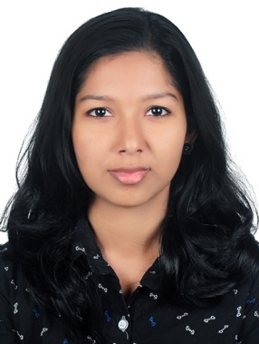
Mob : C/o 0502360357

OBJECTIVE

In quest of professional opportunities for utilizing my skills and abilities in computerized industries that offers professional growth while being resourceful, innovative and flexible. Willing to work as a key player in challenging and creative environment.

EDUCATIONAL PROFILE:

 |  |  | Year Of
Qualifications | Institution | University/Board | Passing | Marks (%)
B.Tech Computer | Sahrdaya College of | University Of Calicut | 2017 | 72
Science and | Engineering and Technology
Engineering
Plus Two | National Higher Secodary | Kerala Board of Secondary | 2013 | 92
 | School,Irinjalakuda | Education
SSLC | Little Flower Convent Higher | Kerala Board of Secondary | 2011 | 100
 | Secondary School,Irinjalakuda | Education

TECHNICAL SKILL:
OPERATING SYSTEMS : Windows 98/XP/7/8,Linux
MS-OFFICE : MS Word ,MS Excel,MS Powerpoint
PROGRAMMING LANGUAGES : C, C++, PHP, HTML,CSS,JAVA
DATABASES : MySQL

ACADEMIC PROJECTS:

Minor Project:
Website on Roadsafety
Website providing guidance and information for all road-users
Role: Worked as a web developer in creating front- end and back- end systems for the website using
web technologies such as PHP, CSS, HTML, Javascript.
Major Project:
Iot NextGen Bed

In this project we aim to design a smart bed that could be used as aid for bedridden people.
The bed is made up of a number of modular sections(hexagonal stools) that can be moved around
to creating different positions according to command given from user via internet.

ACHIEVEMENTS:

- Completed Internship from Pepperport System & Solutions Pvt.Ltd.
- Completed course on PHP,HTML & MYSQL from Own Manager ,Thrissur.
- Attended 2 day IoT challeng workshop on in connection with IIT-B Tech
- Attended Microsoft Azure one day workshop conducted by Innovation and Entrepreneurship Development Center (IEDC)

PERSONAL STRENGTH:

- Flexibility and adaptability to work in any environment
- Punctuality
- Ability to work as individual as well as in group
- Hardworking
- Positive attitude

PERSONAL PROFILE:
- Nationality : Indian
- Date Of Birth : 10/03/1995
- Marital Status : Single
- Linguistic Ability : English and Malayalam
- Visa Status : Visting Visa

DECLARATION:

I Hereby inform you that all the statement made above are true the best of my knowledge and belief.

(Nijisha)

