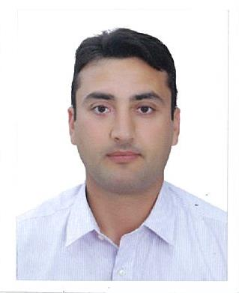
Sadam
Citizenship :- Pakistan ▪ Date of Birth :24.01.1986
Languages : English, Urdu
Contacts:-
Tel : C/o 0504973598
E-mail sadam.378905@2freemail.com

Profile :-
Personal Statement:- | I enjoy challenges, which I love to face with diligence. I require and exude excellence in everything I purpose my heart to do. I enjoy teamwork; believe in discipline and in ensuring that all players are willing and able to do the best in them. I believe in efficiency, diligence and positive thinking and work well done under little supervision. Loyal to the service and causes involved in. Most of all I believe in fairness, honesty and integrity.
Objective:- | I am seeking a position within Finance Department, possibly with an international perspective that will help and enable me to advance in my career as Accounts Receivables and related departments.

Basic Skills:-
Communication:- | Deals with internal and external customers at all levels via telephone and email, to ensure successful communication via actively listening and probing questions
Problem solving:- | Resolves in-depth queries in a methodical manner independently and with internal and external business partners to find appropriate resolutions, efficiencies and high level of quality.
Planning and Organizing:- | Refined planning and organizational skills that balance work, team support and ad-hoc responsibilities in a timely and professional manner
Team Player:- | Enjoys sharing knowledge and encouraging development of others to achieve specific team goals
Punctuality:- | Make sure that my work is submitted on timely manner and my attendance is as per the company policy without failure.

Education:-
2007 | MBA Finance Federal Urdu University Islamabad (Pakistan) Continue
2005 | B.Sc. Mathematics and Statistic ,  Malakand University (Pakistan)
2003 | FSC PRE Engineering University of Peshawar(Pakistan)

Working Experience:-

Served as a waiter Islamabad Serena Hotel Dec2009 to Sep-2011(Member of Leading Hotel of the World)

Served as a Night Auditor Tangram Hotel Erbil (November 2012 to Jan 2015)

Served as a Income Auditor Tangram Hotel Erbil (January 2015 till to date.

Software Using:-
- Sun System (Accounting)
- Opera (Outlet Operation )
- Micros (F&B Outlet)
- FMC (Material Management)

Key Responsibilities:-
- Daily Revenue Report
- Manager Flash
- Guest in-house control
- Revenue Reconciliation Micros Vs. Opera Vs. Sun
- Room Reconciliation
- Rate Check Report by Market
- Rate Change Report
- No-show (Justification)
- Complimentary Rooms
- Discounts & Rebates
- Refund & Paid-out
- Breakfast Reconciliation Report
- Early Check-in & Late Check-out Report
- Rate Variance Report
- Today Arrival Report
- Guest in-house: Exceeded Credit Limit

- 100% Discount / Complimentary Meals
- Reductions / Other Discounts / Void

- Discrepancies Report: Cashier Report Vs. Actual Drop
- Drop & Withdrawal of envelopes
- Foreign Exchange / Change
- Corrections (if any)
- Spot Checks (if any)

Activities:-
- Preparation of monthly Invoices.
- Preparation of monthly payment.

- Submitting report to the Management as per their requirement.
- Well experienced in Accounts up to Finalization and all Accounts related jobs.

