Curriculum Vitae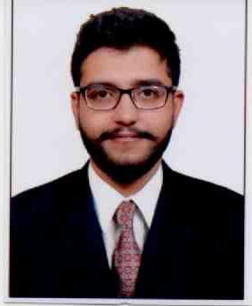

Nauman
Dubai-UAE
Mob: C/o 0505891826
Visa status- visit visa
Email Id: nauman.378923@2freemail.com

CAREER OBJECTIVE:
To work sincerely and diligently for my organization, taking my organization towards sustainable grow by using my academic, technical and inter-personal skills which will not only provide me with ample opportunities to learn but also to grow with the organization.

AREAS OF STRENGTH:
- Enthusiastic Learner
- Commitment towards completion of assigned tasks in right way.
- Good communication and temperament for teamwork.
- Good listener
- Multitasker skills
- Creative

EDUCATIONAL QUALIFICATION:

Completed bachelor of mass media in advertising from lords universal college MUMBAI | First year in June 2015 | E grade
Lords universal college | Second year in March 2016 | C grade
Lords universal college | Third year in April 2017 | D grade
Computer skills basic knowledge
H.S.C COMMERCE, MUMBAI UNIVERSITY | 2013-14 | 53%
S.S.C MUMBAI UNIVERSITY | 2011-12 | 48%

PERSONAL PROFILE:

Date of Birth : 07/09/1996
Gender : Male.
Nationality : Indian.
Marital status : Single.
Languages Known : English, Hindi & Marathi.
Hobbies : Interest in Music & Entertainment.

DECLARATION:

I Hereby Declare That The Information Furnished Above Is True To The Best Of My Knowledge.

Date:__/__/______
Place: Vasai (E). (NAUMAN)

