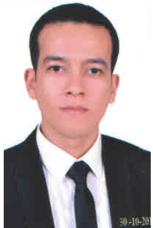

Hesham

Education

- Graduated from the faculty of agricultural sciences department of horticulture(2009).
- Ms.c. in agricultural sciences (Horticulture - Floriculture ).
- ICDL certificate.

Work Experience

Judicial expert in the ministry of justice ( Agricultural expert ) since 2013.

Language

English  Arabic | Quite good.  Native Language.

Technical Proficiency

Platforms  Applications | Mac OS X Leopard, Windows XP/Vista/7/8/10.  Microsoft Office, Landscape design.

