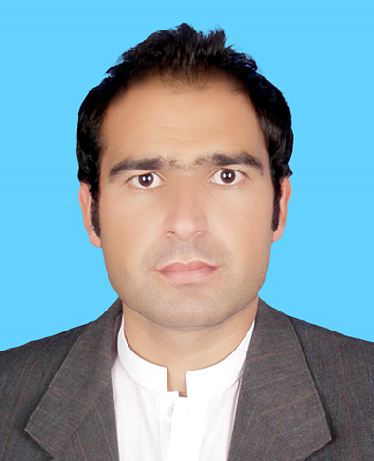QASIM
visa valid till 24/05/2018
Email: qasim.378993@2freemail.com
. CELL # C/o 05016865421
SHARJAH UAE

Objective:
To utilize my professional and practical knowledge by working as a Pharmacist in the field of medicines, as it provides the experience and knowledge that can improve my skills and enhance my career in the field of pharmacy.

Academic qualifications

DHA | Qualified | DHA/LS/2082017/741558
PHARM-D | Sarhad university | 2015
F.S.C (pre medical) | Bise swat | 2008
S. S. C | Bise swat | 2006

Work Experience

1.TWO YEARS EXPERIENCE IN UNITED ARAB EMIRATE AS RETAIL PHARMACIST.

2. .PHARMACIST AT AL SAIF MEDICOSE ( PAKISTAN ) 1st JULY 2015 TO 23th MAY 2016

3.VALID U A E DRIVING LICENSE

Duties and Responsibilities
- Pharmacists give patients medical advice based on their symptoms.
- Pharmacists also may assess the quality of medicines.
- Excellent customer service and inter-personal skills.
- Check the stock expiry on monthly basis.
- Maintain the stock of medicines properly.
- Instruct patients on how and when to take prescribed medicines.
- Inform them about any side effects they may face from taking the medicines.
- Ensure the health and safety of patients.
- Enter Purchase Bills into Accounting Software and handle cash-counter.
- Make sure medicines are stored appropriately and securely.
- Ensure to organising the pharmacy in an efficient manner to make the identification of products easier and faster.

Computer Skills:
- Software(PHARMACY PLUS)
- Pharmacy inventory control management :Making order , entering purchase receive, stock checking, expiry management and barcoding.
- MS Office
- Medical coding

Language

. English arabic.hindi , .Pashto .

Personal skills
- Willingness to learn and work in team.
- Capable of adapting to new environment
- Good communication skills.

Personal Information:
Date of birth: Jully 5th 1990
Marital status: single
Citizenship: Pakistani
Current address: united arab emirate

