KETAN
Contact- C/o 0502360357
Email- ketan.379007@2freemail.com
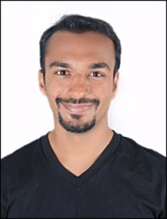

Objective

To work in a stimulating and challenging environment that would facilitate the maximum utilization and application of my broad skills and expertise to make a positive difference to the organization, looking out for a profession in Choreography.

SKILLS

Result Oriented, Proactive and professional dancer with around 20 Years of experience in Dancing Industry among others; Solutions focused, ability to work in both independent and collaborative work milieu.

experience

- Owner at SK Academy Of Dance ( Nov2015 – Present )
- Has worked on projects such as School Annual day, Marriage functions, Independence Day, Christmas and Diwali Celebrations, Railways Navratri function, etc
- Having 8 years of experience in Indian Folk Dance ( Garba and Dodhiya )
- Worked at SDIIPL in Victory Art Foundation as Assistant Instructor for 7 years ( ShaimakDawar International Institute Private ltd ). (2008 -2015 )
- Received “Certificate Course in Yoga- June2017 with A+ Grade from Lakulish YOGA University Ahmedabad

achivements

- Participated in Indias Got Talent Season 4 – semi-finalists.
- Performed in IPL Extra Innings live performances.
- Participated in Deal or No Deal show as contestant.
- Worked as a troop dancer inbollywood film - JaggaJassos.
- Worked as a troop dancer in kannada film – Prasad.
- Won Udaan Competition – 2017 ( 50,000 Student Schlorship at Terence Louis )
- Won Navratri competition at FalguniPathak
- Won many more prize at various Navratri competition and local dance competition

languages known
English, Hindi and Gujarati.

personal information

Date of Birth : 12th May1986.
Height : 158.2 cms.
Weight : 55kgs.
Nationality : Indian.
Martial status : Married.

KETAN

