SHANMUGA
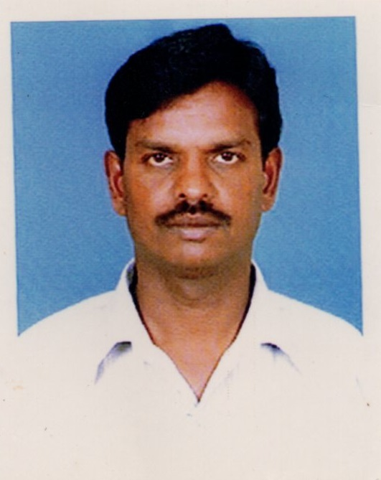
C/o 0501685421
E: shanmuga.379010@2freemail.com

Objective:
Seeking a Seniorposition as Heavy Truck Mechanic with Pro-active and results oriented professional with over 15 years of broad experience in all aspect of Heavy Vehicle mechanism in a fast phase TransportationIndustry.

Work Experience
- DP World , DUBAI, UAE[ May 2011 to till date ]
Class II Mechanic in Plant Workshop

- General Transport L.L.C , Abu Dhabi, U.A.E [ Apr2010 to Apr 2011 ]
Heavy Diesel Mechanic

- Sharjah Ports, Korfukan, U.A.E[ June 2008 to June 2009 ]
Plant Mechanic

- SaudiLand Transport Riyad , K.S.A[ Dec1988 to Apr 2006]
Mechanic

Vehicles Serviced
BRANDS
- VOLVO
- MAN
- MERCEDES BENZ
- ISUZU
- SCANIA etc.,

VEHICLES
- RTG’S TUG MASTERS
- TRAILERS
- TOP LOADERS
- SIDE LIFTERS
- FORKLIFTS etc.,

Educational Qualification’s
- AUTOMOBILE COURSE
Indian Technical Institute, Tamilnadu, India.

- ITI FITTER
Government ITI Trichy, Tamil Nadu, India

Training Course Attended
- Training Course in Diesel Engines
- Training Course in precession tools and measurement
- Training Course in pneumatic brakes

Driving License
- UAE Driving License - No2
- KSA Driving License - Light Vehicle

Languages Known
English, Hindi, Malayalam, Arabic & Tamil

Personal Profile
Gender/Sex | Male
DOB | 16th March 1963
Marital Status | Married
Nationality | Indian
Present Location | Sharjah
Visa Status in UAE | Employment Visa (NOC)

Reference
Will provide upon request

