123

SEKHAR

HR ADMINISTRATION/SALES & MARKETING/OIL & GAS INDUSTRY

Characterized as a strategist & implementer with excellence in office management, sales and administration skills in oil and gas industries with focus on accomplishing organizational goals.

Industry Preference: Sales or Administration/Oil & Gas Industry

sekhar.379028@2freemail.com C/o 0505891826

Profile Summary

Innovative and extra-dynamic in providing secretarial and coordination supports to the management in order to run the project smoothly with 4 years of experience in the Gulf with cross-cultural experiences. Dealt with very confidential and sensitive especially during the period of company’s tender submissions and recruiting manpower’s through agencies. Experienced in all types of administrative jobs & fast learner to learn a different programmed used by different organization. responsible for supervising and monitoring of all company provided guards (50nos.) & assets on the site of Qatargas, H.O. Doha. Ensuring security requirements are met by all contract guards in relation to the security contract. Participating in all CONTRACTOR issues related to COMPANY security guards and liaising with the company for all administrative & operational requirements.

Seeking for a good opportunity through which my skills and passion for excellence will be utilized.

Education

2017 CPO (Certified Protection Officer)
International Foundation of Protection Officer

2015 NIELIT “O” Level (National Institute of Electronics and Information Technology)
Asian InfoTech, Guwahati, Assam, India

2012 ADCA (Advance Diploma in Computer Applications)
Asian InfoTech, Guwahati, Assam, India

2011 PGDCA (Post Graduation Diploma in Computer Applications)
NICET Computer Institute, Digboi, Assam, India

2011 Intermediate (XII)
Rashtriya Vidyalaya Higher Secondary School, Digboi, Assam, India

2007 | Higher School Leaving Certificate-HSLC (X)
 | Adarsha Hindi Vidyalaya HS School, Baragolai, Assam, India
Soft Skills |  |  |  |  |  | Core Competencies
 |  |  |  |  |  | Office Administration
 | Team Player | Trouble Shooter | Analytical
 |  |  |  |  |  | Security Reports & Document Control
 | Collaborator | Communicator | Innovator
 |  |  |  |  |  | Security Survey and Reporting
Professional Trainings |  |  |  |  |  | Risk Assessment and Drills & Exercise

• Basic First Aid Training
 |  |  | Cross-Function Coordination
• | Basic Fire Fighting Course
• | Basic Radio Communication

- Office Safety & Emergency Response Program

- ePTW (Electronic Permit to Work)

- H2S/ BA Certification

- HSE Induction and Heat Stress Management

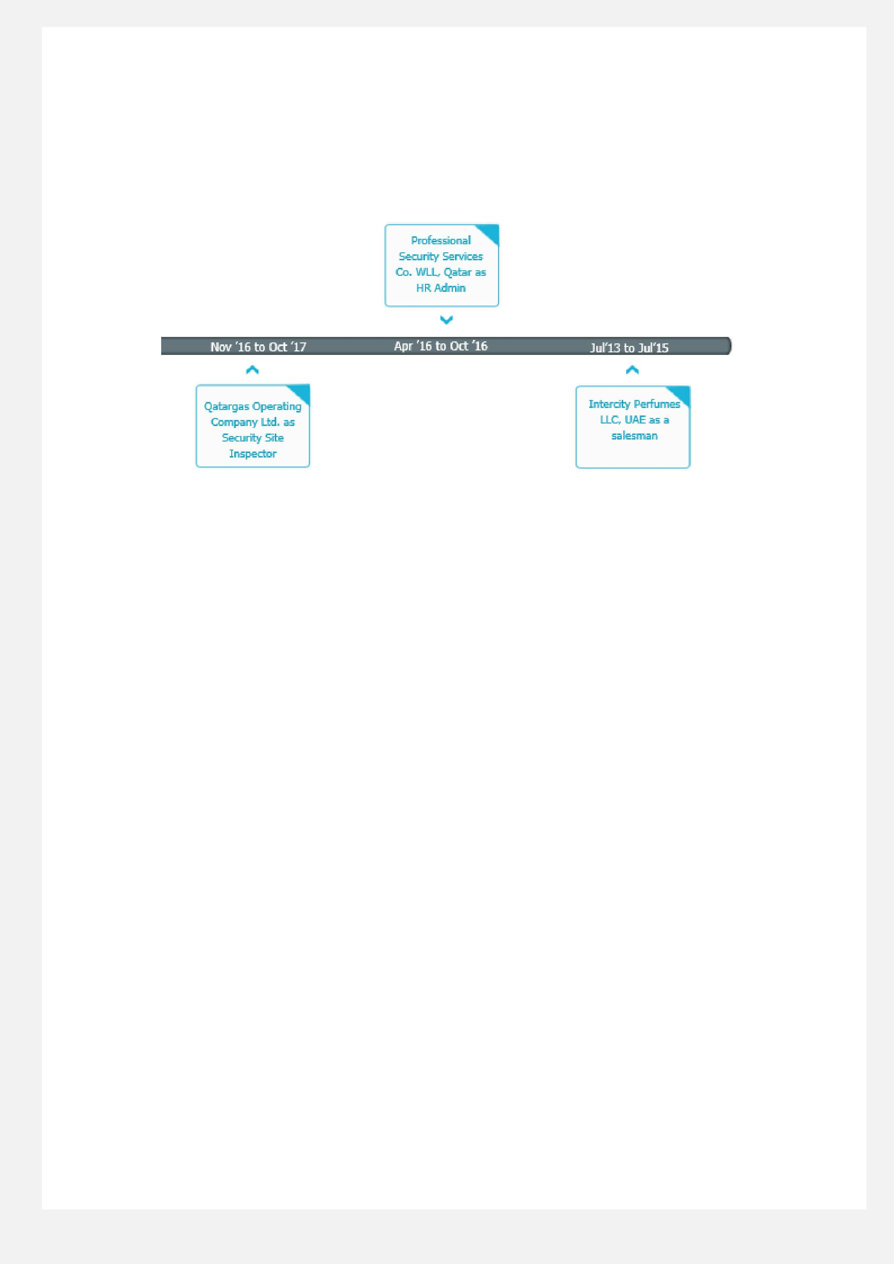

Career Timeline

Work Experience

Nov ’16 to Oct ’17 Qatargas Operating Company Ltd., State of Qatar

Site-Inspector (Contract)
Role:

- Responsible for monitoring of security guards on Qatargas site to ensure they meet security requirements based on the security procedure described by the client.
- Takes active role in selecting candidate for QG, based upon set recruitment criteria.

- Organize and maintain calendars of Head of Security and Security Supervisors for the meeting arrangements and record meeting minutes.

- Maintaining security guard leave schedules and organizes relievers to attend and cover the position in order to meet the operational requirement.
- Maintains records of attendance for security guards and prepare the salary sheet for company purposes.

- To prepare payment summary invoices and process on a monthly basis based on timesheet reviewed and approved by client.
- To provide access to Access Control Systems (e.g. Lenel) for the employees, contractors and visitors.

- To prepare and maintain EMS KPI tracking sheet on a weekly basis.

- To accumulate and forwards QG Security Weekly Major Highlights to EMS&S Manager.

- Responsible for entire administrative activities on site.

- Assist Head of Security & Security Supervisor during the course of revalidation of security plans and procedures.

- Prepare and upload Security Performance Report (SPR) and Security Operations Realization Database (SORD) reports.
- Revalidate existing and prepare new Post Orders for all security locations.

- Liaising effectively with transport department of the company for the smooth movement of the security guard on location(s) & event(s).
- Conduct Security Survey of existing and prospective security locations.

- Maintain Bio-Data, Training Index of all contract security personnel in their respective personal files.

- Conducting disciplinary interviews for guards who are performing below standard and assigning the appropriate training to enhance the standard of security knowledge.

- Takes an active role in assisting QG Security Supervisor's to ensure security staff confirms to contractual obligations.

- Visits individual QG Security Supervisors on a daily basis - Doha & Ras Laffan and expansion projects.

- Conducting safety Risk Assessments & Tool Box Talk on COMPANY facilities.

- Be on call to assist COMPANY Security Supervisors in relation to matter regarding contractual performance and administration.

- Attending the safety committee meeting on monthly basis in order to register the issues related with safety and security.
- Assisting the client-supervisor with all secretarial functions and fulfils the operational requirements in time.

Apr ’16 to Oct ’16 Professional Security Services Co. WLL, Qatar

HR Admin
Role:
- Scheduled meetings, prepared agendas, meeting notes and correspondences.

- Maintained personal records using information technology equipment’s.

- Assist HR Managers to obtain temporal staff from contract agencies & assist to process their visas.

- Carry out payment processing by calculating employee salary, distributing checks, & maintaining payroll records.

- Prepare paperwork for human resource policies & procedures.

- Process employee’s requests and provide relevant information.

- Update human resources databases by inputting information on new hires, separations, vacations, & sick leaves.

- Prepare passes, identification cards and badges for employees according to their ranks and job designations.

- Maintain all the records & update database of trainings & additional coursed done by the company employees.

- Preparing timesheets for the employees working in client’s facilities in order to process their salary.

- Assist accounts team at the time of giving settlement to the resigned staffs and process their documentation.

- Maintained calendar and appointments for Managers & updated company database of clients.

- Answered phones, processed expense reports, travel, and budget management for the department.

- Ordered office supplies and equipment, Printed reports, mailings and summaries from database.

- Maintained confidential client files and information.

July’ 13 to Jul’ 15 Intercity Perfumes LLC, Dubai, UAE

Salesman:
Role:
- Greeting and acknowledging every customer.

- Establish trust with customers for better sales.

- Deal with customers through telephone effectively.

- Handle Purchase Requisition, LPO, Payment Request and Petty Cash, Duty Roster and Timesheet.

- Watch for and recognize security risks and thefts, and know how to prevent or handle these situations.

- Place special orders or call other stores to find the desired items for customers.

- Sell or arrange for delivery, financing, or service contracts for merchandise.

- Maintain knowledge of current sales and promotions, policies regarding payment and exchanges, and security practices.

- Compute sales prices, total purchases and receive and process cash or credit payment.

- Attend weekly management meeting, leasing committee meeting and steering committee meeting and record minutes of meetings.
- Prepare and update a comprehensive report of pending issues related to all the sales department of the organization.

- Participated in Emergency Evacuation Drills during Opening and Closing hours of the shop.

- To attend problems of the customers and forward the concerned matters to the Shop Manager and ensure that those problems are resolved.
- To provide visitors and customers with a positive shopping experiences.

- Achieving given individual target of sales & worked with the Sales Team Members to achieve the goal.

- To undertake all other tasks relevant to Sales & Marketing.

IT SKILLS
- Microsoft Office (Microsoft Word, Excel, Power Point, Outlook), 30-40 wpm typing speed in English.

- Operating System: Windows XP/7/8/10/Vista, UBUNTU

- Web Designing Tool: Adobe Photoshop, CorelDraw Graphic Suite

- Other Technologies: MS Office, Tally, C, C++, RDBMS (SQL), E-Promise (ERP), SAP-Workflow Portal

- Other Skills: Computer Hardware and Networking, Troubleshooting Computers

Personal Details
Date of Birth: 15th November 1992
Languages Known: English, Hindi and Nepali

