RESUME
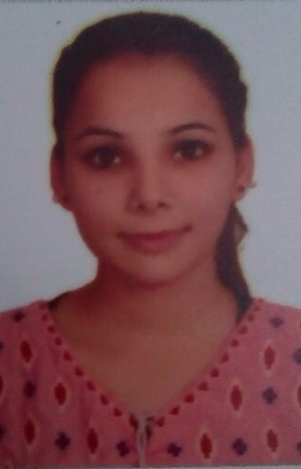
Seema
C/o-Mob. +971504973598
Email:- seema.379054@2freemail.com

CARRIER OBJECTIVE

- To enhance my knowledge of skill in order to deliver services with best of my
excellence for the achievements of common goals of organization & society.

CURRENTLY WORK EXPEREINCE

I have +2.9 Year Total Experience in the field of Retail, Super Market, Restaurant & Shopping Mall. Presently I am working with King and Queen Restaurant LLC.

EXPEREINCE DETAILS

- Working with King and Queen Restaurant LLC. UAE From Sep, 2017 to Till Date. (Second VISIT VISA with King and Queen Restaurant as a Cashier. From 2 February 2018 to 2 May 2018)
- Job Profile: Presently working with King and Queen Restaurant LLC .UAE . as a Cashier.

- 1 year Experience as a Cashier / Receptionist in Aman dental clinic.
- 1.5 Year Experience as a Receptionist in Pooja beauty parlour india.

COMPUTER KNOWLEDGE

- MS office (MS Word, MS Excel) Power Point Good typing speed.
- Specialization in Accounts Course.
- Knowledge of Internet applications etc.

EDUCATIONAL QUALIFICATION

- 10th From Punjab Board INDIA
- 12th From Punjab Board INDIA

LANGUAGES KNOWN

- Hindi, English & Punjabi.

PERSONAL DETAILS

Father’s Name : Sh. Pappu Sehgal
Date of Birth : 10-07-1996
Marital Status : Unmarried
Nationality : Indian

DECLARATION

I hereby declare that the above information is true and correct to the best of my knowledge and belief.

