CURICULAM VITAE
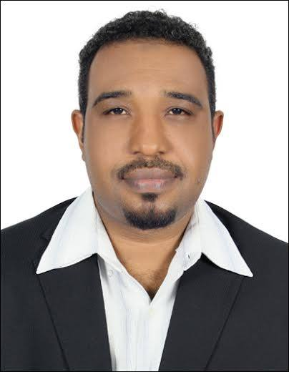

- OBJECTIVE:
I am a highly motivated hard working person looking for a major career shift to have new experiences and to expand my knowledge to another new level.

- PERSONAL PROFILE:

Date of Birth : 29/05/1970
Sex : Male
Marital Status : Single
Nationality : Sudanese
Permanent Address: U.A.E – Dubai – T Com
Visa Status : Work permission

- EDUCATIONAL PROFILE:
- Omdurman Ahlia University - Republic of Sudan
Faculty of economic & Administrative Sciences
B.Sc. of Executive Secretariat & Office Management –In 27-02-2005
- The London Academy for Training and Education – UK
Mini Master in Total Quality Management & Excellence (60 Hours)
- Higher Council for Total Quality & Excellence – Alroia Alsabaa for Management Training & Human Resources Development – The Republic of Sudan
- ISO 9001:2015 Awareness & Documentation on 06 – 07 May 2017
- ISO 9001: 2015 Internal Audit on 08 – 11May 2017
- Total Quality Management on 13 – 14 May 2017
- EFQM Excellence Model 2013 on 15 – 18 May 2017
- Balanced Score Cards on 20 – 22 May 2017

- CAREER PROFILE:
  - Bin Aweidah Corporation – holding (19-02-2008 – 16-03-2013)
- Collection officer
- Responsible of the corporation’s companies payment collection in Abu Dhabi, Al Ain, Dubai, Sharjah , Ajman & Fujairah
- Full supervision and follow up with various customers.
- Delivery invoices and related documents which required for clients
- Solving contractsproblems.
- Following and collecting payments from ADNOC, GASCO ….etc.
- Solving Pending problems.
- Presenting weekly and monthly report about the work situation to the direct manager.
- Office Assistants.
- Receive and deliver mails.
- Receiving calls and taking notes.
- The GWB Group International DMCC (18/09/2017)
- Credit Control & Collection

- SKILLS AND OTHER EXPERIENCES:

Computer skills:
- Microsoft office word, Microsoft office excel

Gallant Inventory Application:
- Goods Receipt Voucher – Issue Voucher.

Other experiences :

- Holding a U.A.E light driving license

Languages :
- Arabic Mother Tung
- English Speaking and Writing
- 4 Basic courses of French

Job Description:

I am a responsible of all debt transaction of the Group that composed of (Emirates Distribution & Publishing Agency – Abu Dhabi Gas Company – Emirates Advertising & Publicity Agency – Bin tasks is start from submitting the invoices with other helpers to our customers at the beginning of the month in pan UAE, following and collect the payment from ADNOC, GSCO, Lulu Supermarket Group, Fatima Supermarket Group, Safeer Group, Royal Group, Center point, E-max Electronic, T. Chetrum, Almaya Group, Aldar Real estate, Al-Habtoor Engineering, Al-Shaafar Constricting … etc. Taking general statement from the Account Department and analyze the debits then classify them according to the time and the amount, calling the customers and discuss with them about the payment, if it is ready, I take the receipt voucher beside invoices so as to identify the amount of the cheque or cash which will receive against the invoice. Issuing the receipt voucher it depends up on the company system, some companies are use a manual and the others using a computerize receipt voucher. For the old and complex debits cases it needs to coordinate with the sales department so as to return to the documents that prove the outstanding payment like (RFQ – Quotation – Local Purchase Order “L.P.O.” – Delivery Note) all these documents must be attaches to the invoices and statement. Prepare a report to explain the situation of the collection in Ben Aweidah Electro-Mechanic – Intelligent IT Company Aldhafrah Real estate).

