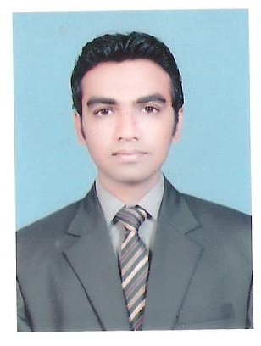

CURRICULUMVITAE

Dr. ALI
C/o-Mobile : +971501685421

Date of Birth | 01 Sep 1991
Nationality | Pakistani
Marital status | Married
Religion | Islam
Email Address | Ali.379088@2freemail.com

OBJECTIVE

- To obtain a position as a Veterinarian in a prominent organization utilizing my education and background experience in small and large animals.
- Always intend to learn the advancements and skills of my profession.
- Always play my positive and active role for the betterment of organization

Educational Qualification

Degree | Grade/  CGPA | Passing Year | Board / University
Doctor Of Veterinary Medicine | 3.43/4.00 CGPA | 2010-2015 | Faculty of Veterinary Sciences, BahauddinZakariya University, Multan, Pakistan
F.Sc  (Pre-Medical) | 1st Division | 2010 | Punjab College,Board of Intermediate and Secondary Education,Multan, Pakistan
Matric | A+ | 2008 | Zamir Public School, Board of Intermediate and Secondary Education, Multan, Pakistan

Summary of Qualifications
Registered veterinary medical practitioner by
PAKISTAN VETERINARY MEDICAL COUNCIL
All educational documents are attested by
MINISTRY OF FOREIGN AFFAIRS AND UAE EMBASSY ( Equivalence done )
9 months UAE field experience in Medicine and Surgery
Holder of a valid UAE light vehicle DRIVING LICENCE

Work Experience and Achievements
At present working at a private clinic.
Internship at DISTRICTPOULTRY DIAGNOSTIC LAB, Multan, Pakistan from 1 feb to 31 May 2015
2 Years veterinary practice at
University Veterinary Clinic and University satellite Clinic
Participation in 1st International Conference on Zoonosis (16-17 Oct 2014) organized by
FVS, BahauddinZakariya University, Multan, Pakistan
Participation in Seminar/Workshop on Biosafety and Biosecurity Issues-Health, Research and Industry held in Institute of Pure and Applied Biology 10 dec 2013
(PAK)
Organizer of FANCY BIRD EXHIBITION 2011 By
MULTAN FANCY PIGEON SOCIETY held in FVS BZU Multan (PAK)
Participation in National Conference on
Strategies to Improve Red Meat Production
In Pakistan ,13Th October, 2010
Awarded Laptop by
Chief Minister Punjab, Youth Initiative program (PAK)
Reading, writing and speaking proficiency in English & Urdu

Interpersonal Skills:
- Hard Working
- Self Motivated and Self Initiative.
- Ability to control the critical situation according to the circumstances.
- Good leadership and communication abilities.
- Strong commitment to achieve my goals and tasks.
- Excellent personality and expressing quality in different ways.

Reference:
ADEQUATE REFERENCES WILL BE FURNISHED ON DEMAND.

