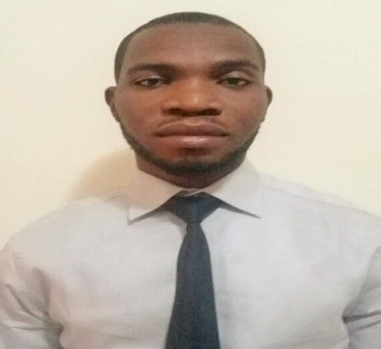
AZEEZ
IT ENGINEER

: azeez-379099@datachampion.com
Dedicated IT Specialist with over 6 years experience in Network administration. An adept in networking, hardware and computer technology problems. Effective in IT traini

Passionate and dedicated IT Engineer with over 6 years experience in IT Network solutions, Routing Protocols, CCTV/IP Surveillance installation and configuration. Well regarded for honesty, self motivation and a team-player with colleagues and clients.
STRENGHT & KEY SKILLS
WORK EXPERIENCE

BIGBOOKS SYSTEM (Feb 2014 – Oct 2017)
(IT Specialist)
- Installation and configuration of wired and wireless networks for staffs and clients.
- Installation and Setup configuration of Cisco routers and Switches.
- Provide IT support to staffs and clients.
- Adding users account to a network, assigning and updating security permissions.
- Monitoring and maintenance of network.
- Web development (HTML, CSS & JavaScript)
- Installation and configuration of CCTV/IP Surveillance.
- Training of fresh intake on Networking, Cabling and Routing protocols.

ITRDN TECHNOLOGIES LIMITED (Jan 2012- Feb 2014)
(Technical Support)
- L.A.N Installation and Troubleshooting (Wired & Wireless).
- Setting up user accounts, permission and password.
- Installation of Windows OS and application software.
- Coupling of hardware and peripherals devices.
- Carrying out minor hardware repair.
- Attending to emails and talking clients through actions to help set up systems or resolve issues.
- Attending seminars for technical update

- Wired Networking
- Wireless Networking
- Routing Protocols: IRP, IGRP, EIGRP
- Subnetting & TCP/IP
- CCTV/IP Surveillance Installation
- HTML & CSS
- JAVASCRIPT
- Software and Hardware Installation
- Microsoft Outlook
- AutoCAD
- Training
SOFT SKILLS

- Analytical & Problem solving skill
- Flexibility & Adaptability
- Good Communication
- Attention to details
- Teamwork

MIMI TECHNOLOGIES LIMITED (June 2010 – Nov 2011)
(Technical Support)
- Installation and configuration of Wired Networking
- Installation of Software, Hardware and Peripherals.
- Troubleshooting and minor repairs of desktop computers.
- Updating self help document for references

MARGINAL MERCHANT NIGERIA LIMITED (2003-2005)
(Sales Representative)
- Providing information to customers about products
- Prepares sales report by compiling data; developing presentation formats and materials
- Maintains customer database by inputting customer profile and updates
- Resolve customer’s complaints by investigating problems, developing solutions and making recommendation to management.
- Monitoring competitor’s activities.

ACADEMIC AND PROFESSIONAL QUALIFICATIONS

- B.Sc Statistics with Computer Science. (University of Benin, 2012)
- Oracle Database Administration (NIIT,2013)
- Cisco Internetworking Devices (Bigbooks, 2014)

ACHIEVEMENTS

- Work as team to install and configure Routers for Cisco branch office, Nigeria.
- Installation of LAN networks for As-Salam College, Lagos, Nigeria.
- CCTV/IP Surveillance Installation for St. Nicholas hospital, Lagos, Nigeria.
- Installation of Windows OS, Applications & Printers for all branches of Manpreet Limited, Nigeria.

PERSONAL DETAILS

Visa Status: Visit Visa ( 90 days)
Language: English
Reference: Available on request

