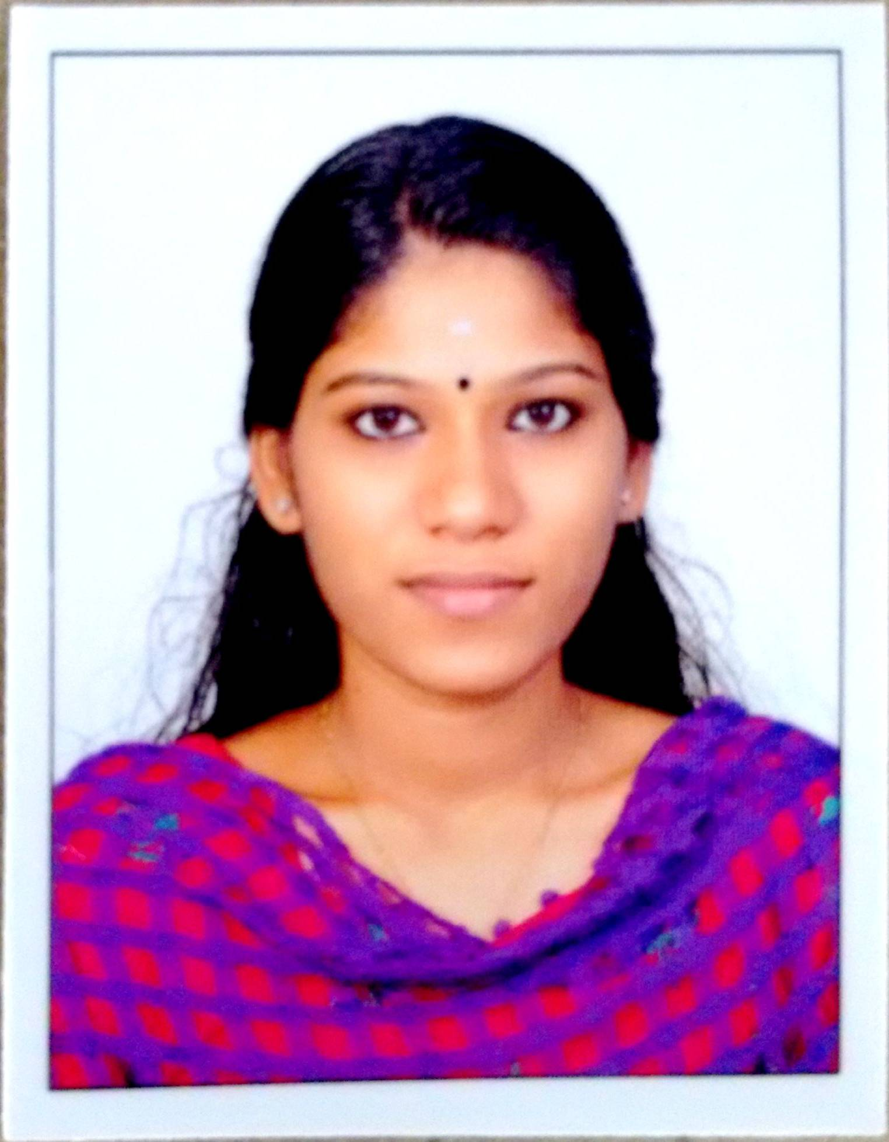
APARNA
Mob: C/o 0505891826
Email: aparna.379115@2freemail.com

CAREER OBJECTIVE:

To secure a position in the industry where my scope of performance is maximum, to gain exposure on the latest cutting edge technologies, to bring out my own innovation, to bring out the maximum creativity that resides within me and effectively contribute to the organization to which I belong and thereby achieve vertical growth Professional Experience

- Company : Govt.Polytechnic College
- Designation : College Administrator

Job Responsibilities :
- Provide administrative support to a team of lecturers, tutors or teachers.
- Manage the student life cycle from registration/admission to graduation/leaving.
- Work with academic boards, governing bodies and task groups.
- Assist with recruitment, public or alumni relations and marketing activities.
- Draft and interpret regulations.
- Deal with queries and complaints procedures.
- Coordinate examination and assessment processes.
- Maintain high levels of quality assurance, including course evaluation and course approval procedures.
- Use information systems and prepare reports and statistics for both internal and external use.
- Participate in the development of future information systems.
- Manage budgets and ensure financial systems are followed.
- Purchase goods and equipment, and process invoices.
- Supervise other administrative staff.
- Communicate with partner institutions, other institutions, external agencies, government departments and prospective students.
- Organise and facilitate a variety of educational or social activities.

- Company : SSPU FORM MANUFACTURING UNIT Designation: : Office Assistant

Job Responsibilities :
- Responsible for all the administrative processes within the Office, as well as providing general secretarial support to enable the smooth and effective running of the office.
- Answering incoming calls in a professional manner.
- Assisted with front desk operations.
- Prepared weekly employee schedules.
- Frequently interacted with guests and sought feedback.
- Assisted with accounting tasks.
- Maintained database of scheduled overnight stays and day visits to the resort.
- Established long-term relationships with corporate clients.
- Supervised hotel staff and worked to resolve staff issues.

ABILITIES

- Good communicational and interpersonal skills.
- Efficient crisis-management skills.
- Dedicated and hardworking team member.
- Successful in working with very tight deadlines.
- Flexibility in adapting to different environments

TECHNICAL SKILLS

Languages : C, C++, Java, HTML, PHP(Basics),Android(basics)
Database : MySQL.
Web Technologies : HTML, XML, CSS, and JavaScript
Operating System : Windows, Linux

PROFESSIONAL EXPERIENCE
- Worked as Administrator with GOVT. POLYTECHNIC COLLEGE, vechoorchira, Kerala for 6 month
- Worked as a OFFICE ASSISTANT with SSPU FORM MANUFACTURING UNIT,Pathanamthitta,Kerala for 2yr

PROJECT AND SEMINARS
Name | Technology
EAAK Secure Intrusion Detection System For MANETs | Java
Online Student Internal Assessment | PHP MySQL
Context-Aware Defenses To RFID Unauthorized Reading And Relay Attacks

ACADEMIC PROFILE

- BTECH in Computer Science And Engineering from college of Engineering Chengannur
- Diploma in Computer Engineering from Govt. Polytechnic college vechoochira
- +2 from St.George Mount H.S.S Kaipattoor
- SSLC from R.V.H.S.S Konni
PERSONAL SKILLS

- Extremely capable of working independently or within a team to achieve set goals.
- Maintain professionalism, confidentiality & effective use of discretions when it is required
- Corporate co-ordination and Time management skills.
- Balancing & prioritizing Multi-tasks accurately & professionally
- Hardworking with Energetic, Positive, Innovative mind & attitude.

PERSONAL INFORMATION
Name : Aparna
Date of Birth : 04-03-1991
Sex : Female
Marital Status : Married
Nationality : Indian
Hobbies : Reading, Writing & Singing
Language Known: English, Hindi &Malayalam

DECLARATION:
I hereby declare that the above statements are true and best of my knowledge and belief.

APARNA

