CARRICULUM VITAE

APPLICATION FOR THE POST OF CIVIL SITE SUPERVISOR / ENGINEER

e-mail: harishankar.379129@2freemail.com Mob: C/o 0501685421

OBJECTIVE

PERSONAL PROFILE
A talented, professional and dedicated Civil Engineer To Achieve high carrier growth through continuous process of learning for achieving goal & keeping myself dynamic in the changing scenario to become a successful professional and leading to best opportunity And am willing to work as a Civil Site Engineer in the reputed construction industry.

Name :
HARISHANKAR

WORK EXPERIENCE

Date of Birth : 13/October/1992

Marital Status : Single Gender : Male Nationality : Indian Religion : Hindu
Languages : English, Hindi,
Malayalam, Tamil

- Company Ninfa Builders & Developers pvt.ltd Kochi
Designation Jr. Civil Site Engineer
Period Jun 2014 – Sep 2015

- Company Interio Home Decors pvt.ltd Kochi
Designation Designer Cum Supervisor
Period Oct 2015 – Jun 2016

Hobbies : Driving, Cricket, chess

SOFTWARE SKILLS

- Autodesk Auto CAD
- Autodesk Revit
- Autodesk 3Ds-Max
- MS-Office
- Adobe Photoshop
- STAAD-PRO

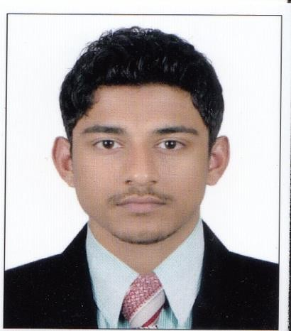

CV of HARISHANKAR [Civil Engineer] 1

CARRICULUM VITAE

- JOB DESCRIPTION

Site Engineer
  - Site inspection for civil construction work and ensure that the work is as per the project specifications and issued for construction drawings / final approved drawings from authorities.
  - Proper management of materials and workmanship.
  - Ensure that all the workers meets the stipulated quality standards
  - Coordinate with subcontractors for smooth flow of work.
  - Inspecting and testing materials prior to their use at site as per sample approved by the consultant and ensuring removal of rejected material out from site.
  - Monitoring daily progress of site.
  - Preparing weekly and monthly progress report to be submitted to the Project director.
  - Making productive report and analyzing.

Interior Designer Cum Supervisor

  - Client Consultation.
  - Design Sketches.
  - Site supervision/Execution, checking and assuring that the work is as per the specifications and drawings.
  - Obtain all necessary approvals and reviews of project design data.
  - Developed specification control drawings.
  - Prepared technical drawings and Plans.
  - Checked drawings for conformity and accuracy.
  - Proper management of materials and workmanship.
  - Conversant with Architect and drawings.
  - Monitoring daily progress of site.
  - Preparing weekly and monthly progress report.
  - Ensuring that all work is done without wastage of material.

CV of HARISHANKAR [Civil Engineer] 2

CARRICULUM VITAE

- EDUCATIONAL QUALIFICATION

QUALIFICATION | INSTITUTE | BOARD/UNIVERSITY | PERCENTAGE | PASSING YEAR
B-Tech | Musaliar College of Engineering | Mahatma Gandhi | 60% | 2014
PLUS2 | Marthoma HSS | Kerala | 74% | 2010
SSLC | J.M.P.H.S | Kerala | 82% | 2008

- PROJECTS

  - Ninfa CASA (Apartment) Ninfa Builders & Developers pvt.ltd Kochi , Kaloor
2014– 2015

  - Interior decors Interio Home Decors pvt.ltd
    - Trinity World
    - MIR
    - KGL
    - Kent villa , etc…. (2015 – 2016)

  - MUD-BAMBOO House College Project (2013)

CV of HARISHANKAR [Civil Engineer] 3

CARRICULUM VITAE

- STRENGTHS

  - Excellent Leadership Entrepreneurial Skills.
  - Ability to work hard and handle crisis situation & face challenges.
  - Capable of working independently and in a team.
  - Self-motivated.
  - Ability to relate with people through effective communication skills.

- TECHNICAL

  - A course of DIPLOMA IN DRAWING AND PLANNING (CAD Centre )Kerala .
  - ANALYSIS & DESIGN OF MULTI STORIED BUILDINGS.

QUANTITY SURVEYING.
  - STRUCTURAL ANALYSIS & DESIGN by manual and using STAAD-PRO .
  - A course of 3D MODELLING (Autodesk Revit). (CAD Centre) .
  - A course of 3D MODELLING (Autodesk 3Ds-Max). (CAD Centre).
  - Excellent knowledge in TOTAL STATION Surveying.
  - Excellent knowledge in GOOGLE SKETCHUP.( 3D –MODELLING).

- DECLARATION

I hereby declare that the information furnished above is true and correct to the best of my knowledge and belief

Place : INDIA HARISHANKAR

CV of HARISHANKAR [Civil Engineer] 4

