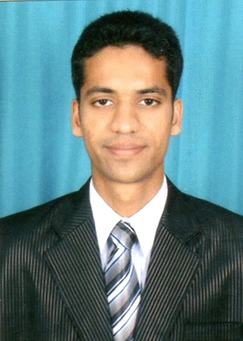
RICKY

PERSONAL DATA :

Mobile No. : C/o 0505891826
Email ID : ricky.379134@2freemail.com
Languages Known : English, Hindi, Konkani & Marathi
Date of Birth : 11th January, 1990

EDUCATIONAL QUALIFICATION :
- Passed T.Y.B.Com Examination from CLARAS COLLEGE OF COMMERCE (2011)
- Passed H.S.C. Examination from ST. MARY’S JR. COLLEGE (2008)
- Passed S.S.C. Examination from ST. XAVIER’S HIGH SCHOOL (2006)

PROFESSIONAL EXPERIENCE :

July 2015 to December 2017 Emirates Airline reservation
POSITION – Customer sales and service agent

- Assisting passengers with Emirates flight reservation.
- Assisting passengers with online visa application procedures.
- Assisting passengers with information about their mishandled baggage.
- Taking passengers feedback complaint and compliment
and which is directly reported to supervisors .

January 2012 to January 2015 Cambata aviation for Cathay Pacific airlines
POSITION-Assistant supervisor ground staff.
- Assisting at check in counters with their boarding pass for business, economy and premium economy class passengers.
- Assisting transiting passengers to other airlines as scheduled.
- Assisting passengers with procedures of mishandled baggage.
- Responsible for day to day smooth flow of operations for arrival departure and direct transit passengers.
- Assisting unaccompanied minors, aged and passengers with special attention through boarding procedures.
- Assisting airline crew through immigration and custom procedures.

HOBBIES: Playing football and travelling

