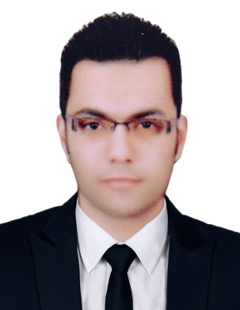
Ahmad
E-mail: ahmad.379142@2freemail.com
Phone: C/o 0504973598
UAE, Dubai

OBJECTIVE Seeking a position as an accountant where extensive experience will be further developed and utilized Extensive experience to the credit.

WORK EXPERIENCE

Yasser Al Marzouqi Al Ajmi Office - Legal Accountant and Tax Expert (Aug 2016 ــ Mar 2018)
Senior Accountant (Al Mansoura, Egypt)

- Bookkeeping for companies and individuals
- Participation in the preparation of budgets
- Preparation of monthly reports
- Preparation and processing of inspection related to VAT
- Attend several workshops concerning the application of the provisions of the VAT law

Khaled Dhafer & Brother co. For Customs Clearance
(May 2015 ـــJuly 2016)

Accountant (Al Riyadh, Saudi Arabia)

- Treasury accounts
- Customer accounts
- Bank accounts
- Prepare monthly reports
- The application of electronic accounting through the program (al shamel accounting(

Vet Green Company Veterinary Medicine
(Feb 2015 — May2015)

Accountant) Al Mansoura, Egypt)

- Customer accounts and suppliers
- Bank accounts
- inventory control
- prepare monthly reports
- The application of electronic accounting through the program ( al zamil accounting )

Rashid sons Mills
(April 2012 — June 2014)

Accountant) Al Mansoura, Egypt)

- Book keeping accounting.
- Restriction daily
- Bank accounts
- Customer accounts and suppliers
- prepare monthly reports
- the final accounts
- The application of electronic accounting through the program ( peach tree)

QUALIFICATIONS
- Certified management accountant, CMA (Partially Certified, pass part one)
- Certified management accountant – part one (Arab academy for science and technology and maritime transport)
- R12.x ORACLE e-business suite Financial Application ( next academy, oracle university)
- The International Computer Driving License
- Advanced business English ) Mansoura University(
- Excellent Microsoft Excel
- Language Skills: -( Arabic) Mother tongue, (English) Expert

EDUCATION Bachelor of Commerce Sep 2007 — June 2011
University of Zagazig

Other
Information

- Date of birth : 16/08/1990
- Marital Status : single
- Visa status : visit visa
- Driving license : Available (Egypt)
- Nationality : Egyptian

Summary

- Five years' experience of Accounting
- Partially Certified management accountant, CMA (pass part one)
- R12.x ORACLE e-business suite Financial Application (oracle university)
- Have knowledge & experience in vat

