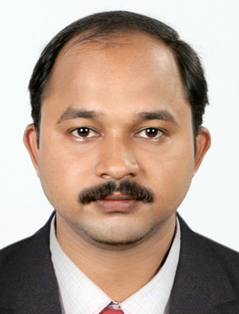

CV of Mr. SAJIL

PERSONAL DATA

OBJECTIVE | : | To obtain a full time position as a social public relation where I can contribute my skills and education in a challenging environment.
MOBILE NUMBER | : | C/o 0504973598; sajil.379167@2freemail.com
Place of birth | : | Ernakulam,Kerala, India
Date of birth | : | 17-12-1981
Sex | : | Male
Nationality | : | Indian
Religion | : | Hindu,Viswakarma
Civil Status | : | Single
Linguistic skills | : | English, , Hindi, Malayalam
\

PROFESSIONAL QUALIFICATION:

Course | Year | Board/Institution | Percentage
M.S.W | 2006 | Sreesankaracharya univesity | 56 %
BA | 2004 | MG University | 65 %
P.D.C | 2000 | MG university | 53 %
SSLC | 1997 | Kerala state board education | 45 %

WORK EXPERIENCE ( 11 YEARS +)

DESIGNATION | COMPANY |  | YEAR
Public Relation Officer | Rajagiri Outreach Service Society., Kalamassery |  | February 2007 –  Sep 2007
Public Relation Officer | MAGJ Hospital, Mookkannoor |  | Oct 2007-Feb 2010
Manager | K.V.M.Hospital ,Perumpadappa , Puthanpally | 01.03.2010 to 31.07.2011
Public Relation Officer | Professional foundation (Institute of Competitive exams) | 02.08.2011 to 28.02.2018

PERSONAL SKILLS
- Able to maintain Professional Relations
- Quick Decision Making
- Responsible
- Good Communication Skills
- Making Creative Suggestions for the development

DECLARATION:
I do hereby declare that the above furnished information is true and correct to the best of my knowledge and belief.

Place: India (Kerala)
Date:
Mr. SAJIL

