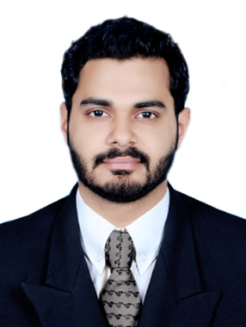
SHARAN
Mobile No. : C/o 0501685421
Email Address: sharan.379173@2freemail.com

Dubai - UAE

OBJECTIVES:

To obtain a position within an organization that will allow me to utilize my capabilities to enhance the profitability and to give opportunities for my organization with my sincere efforts and to innovate new ideas which are always considered as my asset.

ATTRIBUTES:
- Proactive team player with a can-do attitude
- Enjoy challenging roles
- Analytical thinker
- Problem solver
- Attention to detail

WORK EXPERIENCE:

Civil Engineer

Uralungal Labour Contract Cooperative Society Ltd (ULCCS) Mar 2016 – Jan 2018
Vadakara,Kerala,India
- Road construction work under kerala road fund board (KRFB)
- Calicut city road improvement work at Panathumthazha - Cwrdm
- Basketball stadium project at Thalasery
- Football stadium project at Thalasery
- School building construction work at Pinarayi in kannur district
- Auditorium building work at Pinarayi in kannur district
- District flag ship project (DFIP) - Hill highway PWD road work under KRFB in kannur district 59km

Responsibilities
- Structure planning and designing .
- Estimation and billing for project
- Quantity surveying
- Site engineer
- Daily, weekly and monthly report making
- Make sure that the construction cost and production are managed efficiently as possible
- Verify and issue of auto CAD drawing for structural work, plan and assign the work according to schedule
- Follow up with client engineers for resolving site issues

EDUCATIONAL BACKGROUND

- M.TECH in CAD STRUCTURE CIVIL from Sahyadri college of Engineering and management Mangalore 2015 (VTU- Belgaum)
- B.TECH in CIVIL ENGINEERING from KVG college of Engineering Mangalore 2013(VTU-Belgaum)

TECHINICAL SKILLS

• AUTO CAD
• STADD PRO
• SACS
• Microsoft Office

PROFESSIONAL MEMBERSHIPS/ ACHIVEMENTS

- Done project on Fibre Re-inforced Concrete used in Steel fibre and Recron 3s
- Done an individual project in Lift Analysis on Offshore structure and forces in the member due to single ,double and spreader beam lifts
- Participated in National workshop on “CIVIL ENGINEERING CHALLENGES IN 21st CENTURY” on 21st and 22nd February 2014 organized by Department of civil engineering ,(MITE) in association with CAFET-INNOVA technical society, Mangalore
- Participated in a workshop on ”OFFSHORE ENGINEERING AND OPPURTUNITIES” held on 12th November 2014 at Sahyadri college of engineering and management.
- Successfully completed the STRUCTURAL ANALYSIS COIMPUTER SYSTEMS (SACS) training course at the Next Gen institute of construction engineering (P) Ltd from Jan 2015 to Apr 2015.
- Successfully completed STAAD Pro training course at CADD center training services, Mangalore during November 2014

PERSONAL PROFILE

Date of Birth : 09/06/1991

Sex : Male

Nationality : Indian

Marital Status : Single

VISA STATUS : Visit

Expiry Date : 29/04/2018

DECLARATION

To peruse a career that gives me an exposure to various aspect and an opportunity it increase my knowledge and accrue new skills. My caliber also assures you that I would be an asset for your organization

Place: Dubai Signature

Date: (Sharan)

