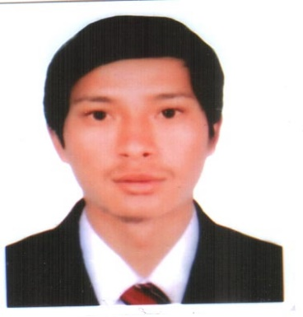
YUKTA
Email: - yukta.379192@2freemail.com
C/o-Mobile: - +971502360357

CAREER OBJECTIVES
I am able to work effectively in a team and own my way. I enjoy a challenges and look for opportunities and develop my potentiality with skill capability. I’ll do on the favor of the company. To thrive on the professional credentials and a seek the challenge job reputed organization and to integrate my SEO/SEM, Internet Marketing, Analytical, software and Microsoft offices skills of my related field Search Engine Optimization, Search Engine Marketing, Internet Marketing, Blogging, Data Entry, Google AdSense, Video Marketing and Video Monetization, Excel, Power Point and Microsoft Word Office etc.
To establish long term career in this company to utilize my innate knowledge and skills with my positive attitude as well as I will maintain the good relationship between company and clients.
ACADEMIC QUALIFICATIONS

- SLC passed from Board of Government in 2009
- +2 passed from HSEB in 2011
- Bachelor of Business Study From Tribhuvan University Nepal in 2015
QUALIFICATION AND SKILLS

- SEO/SEM, Digital/Internet Marketing
- WordPress web designing and Blogging
- Data Entry
- Microsoft office MS
- HTML/CSS
- Social Media Marketing
- Google AdSense
- Video Monetization
- Facebook & Twitter Ads
- Google Webmaster Tools
- Google Analytics and keywords planner AdWords
- Others software Dreamweaver, Zend Studio, FileZilla etc.

WORKING EXPERIENCES

- Extreme Web Soft Pvt. Ltd.:-Feb 2014 to Nov 2014 as Customer Services Representative (CSR)/Sales agent. This company is a Web Designing and Hosting Company which run from USA and this out sourcing business in Nepal. It is Web Designing, Hosting and Domain Registration, SEO and Web Application selling company. Actually I was only handled out bounding calls, keep the detail information of the customers and made the daily and follow up schedule to calls the customers.

- Aladdin Media Inc.:- Jan 2015 – Nov 2015 as CSR, SEO/SEM Specialist and Internet Marketing. This company is IT and also out sourcing company which running from USA. Web Designing, Hosting and Domain Registration, SEO and Web Application selling company. My duties and responsibilities are collect the customizing design and demand of the customer’s then mail forward to the designer and developers. Keep the daily basis customers details and informations. Set up Google analytics, google plus pages, all the key word planner set up in SEO etc. all the on page and off pages search engine optimization for google, yahoo, Bing and MSN.

- Blogging, SEO and Designown Websites: - 2014 to 2016 as a blogger in my websites. I had work Google AdSense with blogging in my website. Specially, I used white hat and black hat both technique of SEO as well on page and off page optimization in my own these websites.

PERSONAL INFORMATIONS

Date of Birth : 29th April 1993
Material status : Single
Religion : Hindu
Language known : English, Hindi, Nepali
Hobbies : Do Surf in an Internet, Travelling, Blogging, Watching Movies

