Anas
Mob: C/o 0504973598
Email: anas.379225@2freemail.com

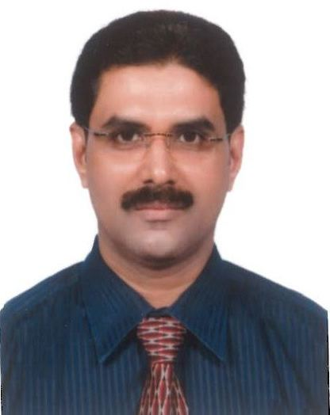
Profile

An enthusiastic, self-motivated and hardworking having master’s degree in commerce, on the lookout for a career in the field of Finance, Accounts or Credit Department, aiming for achievement through determination and dedication

Professional Skills:

- Over twenty years’ experience in the field of Accounts and Trade Finance
- Capable to communicate effectively when dealing with people of diverse interests and levels of authority
- Flexible, quick to learn and able to work well with minimum direction
- Good Office Management skills and a dynamic team player.

Experience:

I) Designation: Credit Officer: Royal Ocean Gen. Trading, Dubai, UAE

Presently working as a Credit Officer since Dec. 2016 in Royal Ocean General Trading LLC, Dubai, a reputed Petroleum and Natural Gas Trading Company.

Nature of Work:

- Preparation of import Letter of Credit, making amendments to the Lc when necessary.
- Managing and accounting of documents under LCs
- Preparation and scrutiny of export Lc documents such as invoice, Letter of Indemnity, Bill of Lading, Certificate of Origin. .….
- Preparation of statement of stock movements and delivery details Report of Nature Gas Transactions and statement of payments and receipts.

II) Designation: Credit Officer: Horizon Energy Co. / Fal Oil Co. Ltd., Sharjah, UAE

Worked as a Credit Officer during 2006 -2016 in Horizon Energy Co. (Fal Oil Company Ltd.), Sharjah, a reputed Petroleum Trading Company having business with oil majors and refineries like Exxonmobil, Shell, Totsa Total, Saudi Aramco, Reliance, Litasco, Glencore, Mercuria, Bapco, Essar and Major Bunker supplier in the Middle East.

Nature of Work:

- Preparation of import Letter of Credit, making amendments to the Lc when necessary.
- Follow up with suppliers and banks for Lc documents
- Liaison with banks for maintaining Credit Facilities
- Managing and accounting of documents under LCs
- Preparing Trust Receipt application and follow up its settlement
- Preparation and scrutiny of export Lc documents such as invoice, Letter of Indemnity, Bill of Lading, Certificate of Origin. .….
- Coordinating export shipments in accordance with the terms and conditions of the Lc
- Assignment of Bunker Invoices to various banks and follow up with Bunker Customers

III) Designation: Senior Accountant in a reputed Engineering Company in Sharjah
During December 1997 – March 2005.

Nature of Work:

- Maintenance of day to day books of accounts.
- Preparation of final accounts and periodical trial balance
- Reconciling bank statements and receivables.
- Follow up of debtors, verification of collection and its deposits in bank
- Preparation of Financial Statements
- Cash flow management of the whole company.
- Customer Support.

IV) Designation: Worked as an Accountant in a multinational import and export
trading Company in Dubai during March 1994 - November 1997

Nature of Work:
- Accounts Payable Management.
>Closely monitoring of chart of accounts.
>Responsible for Global Payable system.
>Managing funds on regular basis.
>Reconciliation of SOA.
- Petty Cash Operation.
- Preparation of Bank reconciliation statement.
- Closely monitoring of GL Entries and other adjustment entries.
- Coordinating in Month closing and Cash flow preparation.
- Providing provision for the month and follow up.
- Preparation of wire transfers and communications with banks.
- Managing all kind of payment like online, check, wire, mass pay, etc..

V) Designation: Worked as a Lecturer in Commerce at Govt Higher Secondary
School in Kerala, India during 1991-1994

Nature of Works:

- Teaching accounts and commerce subjects
- Conducting examinations, valuation of answer papers
- Conducting Seminars, study tours, exhibition, art festival and sports meet..etc

Education:

- M Com- from University of Calicut with Specialisation in Finance Management.
- B Com- from University of Calicut with Cost Accounting being the main subject.
- Exposure in accounting software such as Tally and other Tailor-made packages built on different platforms.
- Thorough knowledge in working with MS Windows, MS Word, MS Excel etc
License: Valid U.A.E light vehicle Driving License

Languages
- English, Hindi, Malayalam, and Arabic

Personal Data
- Date of Birth : September 19, 1965
- Marital status : Married
- Nationality : Indian.

Hobbies / Interests
- Music / Sports / Socializing.

References will be furnished upon request.

