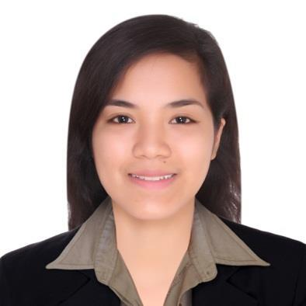

Ellaine.379232@2freemail.com

Philippines

P E R S O N A L D E T A I L S

Birthday: January 18, 1994
Gender: Female
Citizenship: Filipino

L A N G U A G E

Filipino
English

C O M P U T E R

MS Office Good
BizBox Good

H O B B I E S

Singing
Dancing

ELLAINE

P H A R M A C I S T

Motivated and Professional Pharmacist with 3+ years of experience from different fields. A flexible and positive team player with time-management skills seeking for new opportunities and challenges leading to a progressive career as a Pharmacist.

Q U A L I F I C A T I O N S

- Passed the Pharmacist Licensure Examination in the Philippines | June 2014

- Passed the Dubai Health Authority, Pharmacist Licensure | November 2017

E D U C A T I O N

- Bachelor of Science in Pharmacy

Centro Escolar University Manila, Philippines | June 2010 – March 2014

- Secondary Education

St. Mary’s College of Meycauayan Bulacan, Philippines | June 2006 – March 2010

W O R K E X P E R I E N C E

Staff Pharmacist

Valenzuela Citicare Medical Center | March 2015 – January 2018 Km. 14 Mc Arthur Hiway Malinta, Valenzuela City Philippines

During my almost three years of experience in a hospital setting, I got to familiarize more of some medications and its uses. I properly interpret prescriptions, prepare and dispense medications to inpatients and to outpatients with some counseling if possible, including administration routes and dosages. We pharmacists offer information on potential side effects, and check that the medicines are compatible with existing medication. We also communicate directly with physicians and work closely with nursing staff on wards to ensure that the most appropriate treatment is being delivered and prevent medication errors. Lastly, we are responsible for monitoring the supply of all medicines used in the hospital especially the narcotic and controlled drugs with proper documentation of drug count, and are in charge of purchasing and quality testing medication stock.

W O R K E X P E R I E N C E

Compounding Pharmacist
Pascual Laboratories Inc. | August 2014 – January 2015
31 Km. Mc Arthur Hiway Balagtas, Bulacan Philippines

In my five-month experience in a manufacturing plant, it’s where my personal and professional development started. I got to deal with a lot of personalities and perceptions. I was deployed in the solid dosage form department wherein I viewed how the tablets and capsules are compounded, coated and packed. I monitor my operators during compounding if they comply on the manufacturing procedure released in our head office then accomplish the paper works right away. Keeping our environment clean, from the machines, utensils up to the personnel is necessary to prevent contamination. I also check the raw materials upon receiving, from its actual weight up to the final appearance or else it would affect the whole batch and failed to the quality control.

S E M I N A R S A N D T R A I N I N G S A T T E N D E D

- Hospital Pharmacist Engaged in Protecting Patient’s Right and Providing Optimum Patient

Experience | December 7, 2017

- Basic Life Support Training | December 2-3, 2017

- Allied Against Dengue Chapter Seminar | November 19, 2016

- Licensing Seminar For Drugstores and Outlets | November 10, 2016

- Essentials of Excellent Customer Service | July 13-14, 2015

