CIVIL SITE ENGINEER
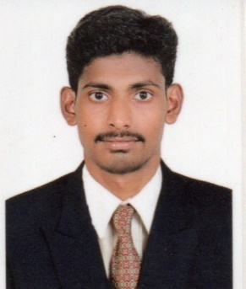
JAGADEESH
Email: jagadeesh.379241@2freemail.com
C/o-Mobile: +971501685421

VISIT VISA

CAREER OBJECTIVE
Seeking for a position of CIVIL SITE ENGINEER. I request you to associate with an organization to provide my skills. Hardworking and eager to get opportunities to improve myself professionally and contribute to growth of the organization with quality services.
PERSONAL QUALITIES
- Eager to learn new things
- Positive attitude and thinking
- Strong motivational and leadership skill
- Best result in crisis situation
- Always willing to innovate new things which can improve existing technology.

EDUCATIONAL QUALIFCATION

- B.E(CIVIL ENGINEERING) with 7.0 CGPA in OXFORD ENGINEERING COLLEGE under ANNA UNIVERSITY in 2017.

ACADEMIC PROJECTS
- Design of Bank Building
- Safe site selection by using GIS
TECHNICAL SKILLS
- MS office
- Auto Cad
- Prima Vera
- Field work
EXPERIENCE
- I worked one year as a CIVIL SITE ENGINEER in MSK CONSTRUCTION COMPANY from Jan 2017 to Dec 2017 with trainings through college management.
PROJECTS
- Residential building
- Commercial building
ROLES & RESPONSIBILITIES
- Planning and Execution of works as per design & drawing.
- Maintaining quality standards for all structural works.
- Supervision of the working labor to ensure strict conformance to methods, quality and safety.
- Execute steel as per approved structural design.
- Study of the related documents such as drawings, Electrical drawings, plans etc.
- Checking the quality of RCC works such as foundations, columns, beams, walls and slabs etc.
PERSONAL DETAILS

Date of Birth : 25/05/1995
Sex : Male
Marital Status : Single
Nationality : Indian
Language Known : Tamil, English &Hindi

DECLARATION
I hereby declare that all the details given by me are true to my knowledge.

Place: Dubai Yours faithfully
JAGADEESH

