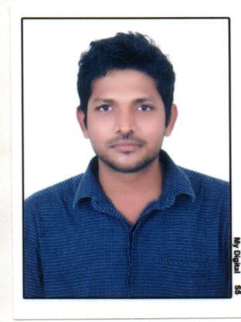Curriculum vitae
Objective
-----------------------------------------------

A Challenging position in a leading firm giving me the opportunity to fully utilize my acquired skills and knowledge and that allow me to develop and progress again
Personal Data
------------------------------------------------------------------
Name : Vinoth
Date of birth : 05/02/1990
Email : vinoth.379258@2freemail.com
C/o-Mobile : +971506425478
Driving license : India
Educational Data
------------------------------------------------------------------

University Degree :B.Sc. Computer science (2011)
University :The SMKC college ( Madras University)
Grade :Good "With Honor Degree"
Experience
-----------------------------------------------

Medical Insurance coordinator

- Dell healthcare from(Apr 2012-May 2015)
- Researched and solved claim and billing issues
- Interfaced with insurance carriers and other healthcare providers
- Assisted patients with eligibility and benefit coverage questions
- Acquired specific CPT and ICD-10 codes to ensure proper treatment and billing of all detailed procedures
- Maintained transaction report for client billing
- Trained employees on various hospital procedures
- Worked as a medical Insurance coordinator at Neltner Business services (Jul 2015-Feb 2017)
- Getting medical approval
- Analyzing the medical claims before submit to the insurance companies such as Authorization and eligibility
- follow up with insurance protocols,
- Claim submission, re-submission and handle both clearing house as well paper claim.
- Resubmit the rejected claims within the TFL (timely filling limit)
- I have deepest knowledge about rejection and billing cycle
- Reporting payment details to the management
- Worked as a medical Insurance coordinator at Ultimate solutions (Apr 2017-Mar 2018)
- Check the member eligibility and provider In-network (PAR OR NON PAR)
- Get the Medical Authorization,
- Submit the claim with appropriate dx(diagnosis ),
- Follow up with claim status after submission,
- Resubmit the rejection claims with an appropriate action for the denial,
- Deepest knowledge about the denial and rejection,
- Follow up resubmitted claim until claim get paid,
- Verified Remittance advice,
- Reported to the management regarding payment and outstanding payment details,
- Insurance Training is conducted by every week

Training courses
-----------------------------------------------------------
- Computer courses at CSC TALLY 7.2 (2009), coronary heart disease project 2009.

Personal Skills
-----------------------------------------------------------

- Spoken Language :English, Tamil,Malayalam, Hindi.
- Personality : Active, Hard worker, team player, Highly Motivated, Ambitious, Trustable and ExcellentCommunications Skills.

