YOUSUF
CONTACT DETAILS

C/o-M:+971505891826
E: yousuf.379301@2freemail.com

Retail store manager

----------------------------------------------------------------------------------------------------------------------------------------
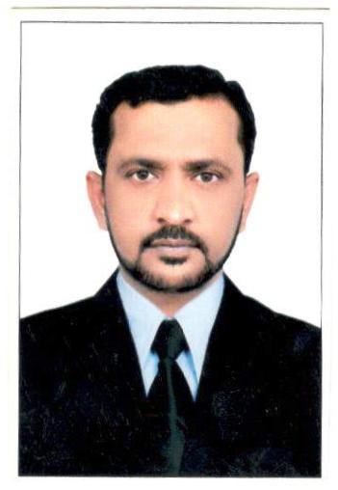
AREA OF EXPERTISE
Retail operation
Store operation
Sales & marketing
Auditing the stores
Product management
Team management
Strategic planning
Cash management
Hiring new staff
AREA OF EXPERTISE
Maximise store contribution through exploiting every opportunity to drive sales, reduce stock loss and maintain cost controls. Delivers the highest level of motivation and development of team members and ensures individual and store compliance with all company regulations and procedures.

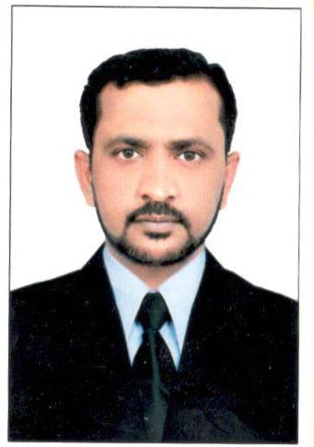
AREA OF EXPERTISE
Plan, control and direct activities of the field sales force to secure maximum sales volume and profit target and to develop maximum potential sales from all market for the company’s product to achieve sales targets in the assigned territory selling existing and new products.
AREA OF EXPERTISE
For flagship stores, or for a combined store unit, leads store/sales managers to maximise store contribution through exploiting every opportunity to drive

PERSONAL STATEMENT
Pro-active and result oriented professional with high experience with program abilities in international brands retail store management, layout planning, strategic planning, achieving corporate objective, delivering exception rather than expectation, managing projects, analysis, team building, people management, market research decision making, training and motivation. Demonstrated hands on management in the development and implementation of strategic plans with proven success in sales and new business development. Fluent in English. Arabic and proficient in Microsoft office products.
WORK EXPERIENCE
Aswar al Bilad trading company–(Saudi Arabia) NOV 2016 TILL DATE
Responsibilities:
- Planned and managed day to day operations for corporate office.
- Coordinating meeting and networking events.
- Analyzed and organized work process and procedures.
- Maintaining office equipment & arranging any repair or
replacement .
- Translate the annual sales plan into quarterly and monthly, weekly
operational plans and develop, on a regional scale, sales target and
volume goals for each products/brands, in conference with the
regional
- manager creating and implementing new administrative system.
Actively tracks sales movement of competitors products and
marketing activities through sales executive channel and marketing
intelligence and communicate exception scenarios to regional
manager.
- Communicates pricing internally and to customers in the area
handled.

APPREAL GROUP OF RETAIL
R&B RETAILS STORES-(Saudi Arabia) September 2014 TO august 2016
Responsibilities:
- SALE: Set and monitor store objectives. Decide on store layout,
stocks positioning, visual enhancement, availability
management. Recommends brand feedback customer request,
and in-store promotions.
- VISUAL MERCHANDISING: Drives highest possible standards of
in-store visual impact. Ensures brand/layout guidelines are
being correctly followed to deliver brand value and ensure
corporate handwriting is evident in presentation. In
conjunction with visual merchandising team, ensure up date
look to window displays. Drives sales floor presentation and
housekeeping/recovery principles to the highest standards by
regular walk through and correct action/coaching.
AREA OF EXPERTISE
Maximise store contribution through exploiting every opportunity to drive sales, reduce stock loss and maintain cost controls. Delivers the highest level of motivation and development of team members and ensures individual and store compliance with all company regulations and procedures.

AREA OF EXPERTISE
Sales. Reduce stock loss and maintain cost controls. Delivers the highest levels of motivation and development of team members and ensures individual and store compliance with all company regulations and procedures. Contributes to and undertakes operations management

minimum possible and achieves its cost targets, and actively seeks out
and implements any additional opportunities to reduce store
expenditure.
- STOCKLOSS CONTROL: Ensure store achieves defined stock loss
targets. Ensure store accurately carries out all loss prevention activities
as defined by their stock loss action plans. Constantly seeks to improve
staff awareness stock loss issues. Actively seeks out and implements any
additional opportunities to reduce stocks loss.
- PEOPLE MANAGEMENT: Initiates and promotes highest standards
of in store training including weekly communication ,daily de-briefs,
product knowledge and on the job coaching. Identifies areas of training
need within the store and develops or arranges programs to address
them. Identifies individuals with potential within the store and
formulates action plan or allocates additional responsibilities to
further their development. Ensure all stores vacancies are filled with
highest quality possible candidates.
- ADMINISTRATION: Ensure store enacts and is fully complaints with
all required administrative procedures according to company guidelines
and within deadlines. Ensures an effective communication of issue and
ideas between store and operational management.

STORE MANAGER

LANDMARK GROUP OF RETAIL

BABYSHOP -MARCH 2009 TO JUNE 2014

- SALES & MARKETING:Planing & scheduling individual/team
assignments to achieve preset goals within quality & cost parameters.
- RETAIL OPERATIONS: Creating initiatives.planing of
merchandising and execution increasing sales drive.planing for
adequate stocks and placing timely orders.incrasing square feet for
return thereby store profitability.
- CLIENT RELATIONSHIP MANAGEMENT: Handling the shop
floor interaction with customers for effective resolution of customer
grievances and obtaining feedback. Maximizing customer satisfaction
matrices by providing sales assistance achieving delivery And quality
norms.
- TEAM MANAGEMENT:Leading,training & monitoring the
performance of team member to ensure efficiency in sales operation and
meeting of individual & group targets. Handling department operation
with a team of 1 department head and 6 team members. Accountability
to ensure attractive merchandise display & over all department.
Conducting meetings for setting up sales objective and designing or
streamlining process to ensure smooth functioning of sales operations.
- MATERIALS/INVENTORY MANAGEMENT: Ensure that all
norms related to stocks holding are met. Supervising the movement of
coming material and unloading in proper location, monitoring
availability of stock making appropriate arrangements to ensure on time
- stock making appropriate arrangements to ensure on time deliveries

PROFESSIONAL SKILLS
English(Fluently)
ARABIC(Good)
Driving License
Fire trained
Basic first aid

PERSONAL SKILLS
Time management
Communication skills
Adaptability
Attention to details
Problem assessment
Decision-making
Hard working
Flexible to relocate any location in Saudi Arabia
Good team player
New network skills
Damage control and loss management
Key account management

ensure reduction in stocks holding & increased stock turnover.

EDUCATIONAL QULIFICATION

Passed B.COM (bachelor of commerce) from (OSMANIA UNIVERSITY,) Hyderabad in 2003.(business law & web programming)

Passed intermediate exams (CEC) in first division in march 2000.form (st.andrews junior college) .Hyderabad.

Passed secondary school exam in 1998 form (al makkah high school).Hyderabad.
Technical proficiencies include: MS access, outlook, excel power point, quick box.

KEYS SKILLS AND COMETENCIES

Motivating others
Impacts
Developing talent
Result focus
Commercial orientation
Customer understanding
Comfortable with windows. MS OFFICE .Excel. PowerPoint and internet concepts
Practical methodical and accurate proven good judgement skills and creative

PERSONAL INFORMATION

- Date of birth : 22nd Feb. 1981.
- Nationality : Indian.
- Marital status : Married.
- Current location : DUBIA (United Arab emirates).
- Saudi driving :exp-04/04/2022
- Languages :English .Urdu .Arabic and Telugu.
- Physical status :Healthy. All immunization correct.

DECLARATION
I do here by declare that all the above particulars are true of the best of my knowledge and belief. Further aim sure that if a chance is given to me to serve in your esteemed organization’s will give my full efforts towards the betterment.

