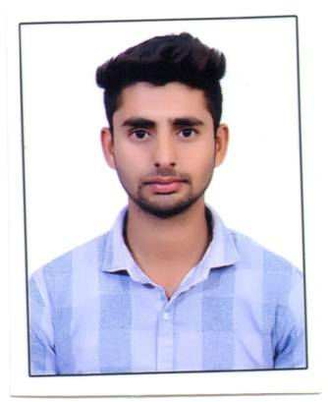

CURRICULUM VITAE

IESSA

C/o-Mobile: +971501685421
E-mail: iessa.379315@2freemail.com
Visit visa
Abu Dhabi U.A.E

CAREER OBJECT
Looking the construction company To work in a challenging environment for a professionally managed and growth oriented organization Where my potentials and experience as a quantity Surveyor can be utilized to their maximum capacity.

PROFESSIONAL PROFILE
- Having 2 Years experience in the field of constructions in both Residential Multi Store Building.
- Displayed proficiency in MS-Office, AutoCAD, Quantity surveyor support and coordinating with team members for achieving the targets.
- I will give my strength, capacity, knowledge & experience to make works assigned to me better.
SKILLS

- Proficient in Auto cad 2D.
- Quantity surveyor
- Software Microsoft Word, Excel Sheets, Power point.
- Strong Communication Skills.
- Good Knowledge of the Engineering Estimation and Construction process.
- Ability to head and motivate.
- Technical abilities and knowledge.

ROLLES & RESPONSIBILITIES:

- Execution of work as per drawing and details
- According to the Work Daily Give the requirement of labor in Head Office for the next day work.
- Day to day checking of civil construction activity.
- Make ensure that all the materials used are according to the specifications.
- Co-ordination with seniors, contractors and client.
- Execute all Civil Work as per the Shop drawing or working drawings & Specifications.
- Do all related task as directed by the construction manager.
- Checking drawing, plans and other qualities to get the accurate calculation of the whole thing.
- Preparing Daily Progress report, weekly progress report & monthly progress report as per the site executions.
- Monitoring the Cube Testing results tested by the Approved Laboratory.

EXPERIENCE DETAILS

Company : SHERRIEFF BUILDERS
Position : Site Engineer
Duration : Jan 2016 to Jan 2018.
Project : Residential & Commercial Building.
Place : Karnataka India.

EDUCATIONAL CREDENTIALS

Diploma in Civil Engineering

R.M Polytechnic Karnataka,

Board of Technical Examination, Bangalore.

S.S.L.C (10th),

The City Academy in, Karnataka.

Karnataka Secondary Education Examination Board, Bangalore.

PERSONAL DETAILS

Date of Birth : 01/06/1996
Marital status : Single.
Languages Known : English, Hindi, Kannada, Urdu,

PASSPORT & VISA DETAILS

DATE OF ISSUE : 10/05/2017
DATE OF EXPIRY : 09/05/2027
PLACE OF ISSUE : BENGALURU

DECLARATION:

I do hereby declare that the above information, which is given by me, is true to the best of my knowledge

