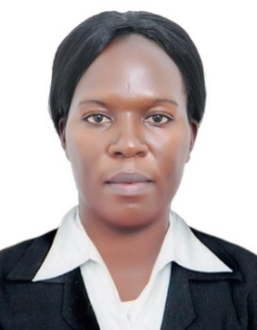
curriculum vitae
Names : Asere

Nationality : Ugandan

Date of Birth : 11/05/1985

Gender : Female

Marital Status : Single

Email : asere.379337@2freemail.com

C/o-Contact : +971503718643

Visa status : visit visa

SECURITY GUARD

Summary
A Security Guard with experience in providing personal, equipment, and real property security in assigned areas; providing information, directions, and escort service as needed.

WORK EXPERIENCE
Security Guard-ASKAR SECURITY SERVICES (2012-2015)
Private Nurse- SAUDI MAN POWER SOLUTIONS COMPANY(2015-2017)
Duties
- Patrol assigned areas on foot or in a vehicle to ensure personal, building, and equipment security.
- Examine doors, windows, and gates to determine that they are secure.
- Inform and warn violators of rule such as loitering, smoking, or carrying forbidden articles.
- Provide public assistance, including lockout services and information.
- Watch for and report irregularities, such as fire hazards, leaking water pipes, and security doors left unlocked; soundalarm during fire outbreak and the presence of unauthorized persons.
- Perform periodic checks of emergency call boxes and street lights to ensure proper functioning; reportmalfunctions as required.
- Prepare routine, standardized reports.
- Perform miscellaneous job-related duties as assigned
ACHIEVEMENTS
- Great skills in utilizing building security and lock system
- Excellent ability to detect problems and report information to appropriate personnel.
- Remarkable ability to understand and follow safety procedure.
- Profound ability to resolve customer complaints and concerns.
- Immense skills in providing protection services to individuals on premises.
- In-depth ability to gather data, compile information, and prepare reports.
- Profound ability to communicate effectively, both orally and in writing.
PERSONAL SKILLS.
- Computer skills(ms-word office)
- Ability to Work under pressure and positive attitude
- Good communication and customer care skills
- Good team work spirit
- Open to new learning
- Ability to remain calm even under stressful conditions

EDUCATION AND PROFESSIONAL TRAINING
SIRA CERTIFICATE (2018)
Certificate of guard force training(2012-2015)
Diploma in Clinical medicine and Community health.(2007-2010)
High School Certificate (A level) 2004-2007)
High School Certificate (O Level) 1999-2002

Hobbies and Interests:
- Reading Articles
- Watching TV
- Playing football

Languages Reading Skills writing skills Verbal skills
English Good Good Good
Luganda Good Good Good
Arabic - - Fair

Referees Available upon request

DECLARATION

I certify that the above information is true and correct to the best of my knowledge and ability if given a chance to serve you, assure you that I will execute my duties for the total satisfaction of my superiors.

