CURRICULUM VITAE
sojo
SOjo.379353@2freemail.com
C/o- +971501685421
.  Visa Visa.  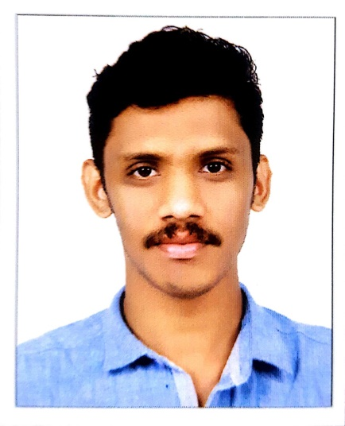  Personal Details  - Age & Date of Birth :  24, 18.05.1994  - Sex : Male  - Nationality :Indian  - LanguagesKnown:  Malayalam, English, Hindi  - Marital Status : Single  . | Objective  To work for an organization with sincerity, dedication and optimizing revenue by insuring streamlined operation. Updating myself on competition and information on trends on regular basis. I do have a strong desire to pursue a carrier; I serve organization and grow successfully in same to do. So I am in search of organization that would offer me challenging, stimulating environment to work in a long with scope, future, career, prospects and individual development. The job that would help me to realize capabilities.
 | Professional Profile

Worked at Smartline décor LLC Dubai,UAE
- As a Draughtsman
- As a Site supervisor

Worked at Home Designers Pathanamthitta, Kerala
- As a Draughtsman
- As a Site supervisor
 | Work History (4 years Experiance)
FromAugust2016 to Augest 2017,Smartline Décor LLC, Dubai, UAE (As interior and joinery Draughtsman)
From April 2013 to May 2016, at HomeDesigners, Pathanamthitta, Kerala

Education
- SSLC (Kerala Board of Public Examination) From St. Mary’s high school pathanamthitta
- Higher Secondary from MPVHS School kumbazha (Board of Vocational Higher Secondary Examination)

TECHNICAL QUALIFICATION
- Draughtsman in civil from MPITI Kumbazha
(NCVT certificate from central GOVT.INDIA)

SOFTWARES KNOWLEDGE
- AutoCAD 2D & 3D : From Autodesk : 5 years Experience

- Revit Architecture :Autodesk 5 years Experience
(also trained and practiced ininformatics Sharjah)
- Microsoft OFFICE applications
Place of Issue :Trivandrum

Date of Issue :21.10.2013

Date of Expiry :20.10.2023

Declaration
I hereby declare that the above mentioned details are correct and true to the best of my knowledge and belief.

Place: Dubai Sojo

