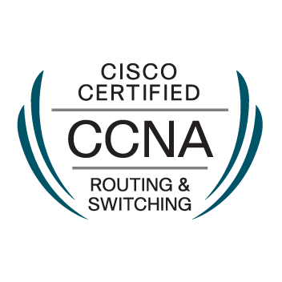
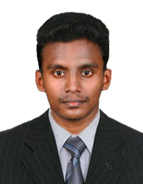
NAFEEL
Email : nafeel.379356@2freemail.com
Contact : C/o 0502360357

OBJECTIVE:
To succeed in an environment of growth and excellence and to get a job which provides job satisfaction and self-development and help me achieve personal as well as organization goals.

SUMMARY

- I have 2.5 years of experience in IT Industry which includes System Admin, Desktop Support.
- I have good experience in Routing and Switching
- Knowledge on Routing Protocols like RIP,OSPF,EIGRP,NAT,PAT.
- IP Configuration Using DHCP or static.
- Knowledge on Microsoft Server 2012 R2 Standard
- Knowledge on Active Directory.
- Created Virtual Machines using Hyper-V and VMWare for Testing the Client Server Relations
- Worked as an Admin and set Restrictions,Priorities and Control Client Computers with the help of Group Policies
- Worked on Vlan Configuration using Switching
- I also Developed 2 Android Apps and Published in Google Play

ACADEMIC CHRONICLE
- Completed B.E. Computer Science and Engineering in St.Xavier's Catholic College of Engineering in Nagercoil-2015
- Completed Higher Secondary in V.K.P.H.S.S in Colachel -2011
- Completed SSLC in Orient Matriculation School in Colachel -2009

TECHNICAL SKILLS
Languages | : Java, C#,HTML,C++.
Technologies | : Android, JDBC, XML, JSON, Selenium, MVC, SQL, JavaScript.
Web Servers | : Xampp,Wamp
IDE | : Eclipse, NetBeans, Android Studio
RDBMS | : MySQL, Oracle,SQLite
Concepts | : OOPS, Design Patterns

Certification:

• Cisco Certified Network Associate (CSCO13287856)
- EMC Cloud Infrastructure and Services

PROFESSIONAL OVERVIEW
Desktop Support Engineer (02/2016 – 03/2018)
AnxoTechnosis, Nagercoil

Roles and Responsibilities:

- Providing application support and troubleshooting applications for users
- IP Configuration using Routing Protocols like OSPF,RIP,EIGRP,NAT,PAT.
- Experience with PC imaging, hardware and software installation/configuration and troubleshooting
- Responsible for managing Microsoft Active Directory to include implementation of GPOs to support the implementation of STIG settings on file and print services, DNS, Domain Controllers and application servers.
- Provide daily technical support for e-mail, network, connectivity, telecommunications, peripheral equipment, and system maintenance. Set up computers and install software for Windows 10.
- Tested BGP features such as EBGP load balancing and Troubleshoot RIPv2, EIGRP and OSPF
protocols.
- Involved in Hardware and Software troubleshooting.
- Planning and configuring the entire IP addressing plan for the client's network and used DHCP toautomatically assign reusable IP addresses to DHCP clients.
- Created Virtual Machines Using VMWare and Hyper-V
- Knowledge on Microsoft Server 2012 R2 Standard
- Created Vlan using Switching
- Monitor Router and Done Regular Backup

US IT Recruiter (06/2015 – 02/2016)
Canvendor Inc, Nagercoil
Roles and Responsibilities:
- Creating job postings on various job boards & LinkedIn
- Experience in sourcing candidates using job boards like Monster, Career Builder, Dice, The Ladder, TechFetch& also in LinkedIn and Google
- Negotiating about the rate (Hourly & Salary) with the candidate and maintaining professional relationship with the consultant
- Maintaining a database about the consultants in excel
- Review and understand technical job requirement requirements.
- Extensively worked with Citizens, Green Card holders, EADs, TN visa holders and H1B
- I have worked with various clients for various IT & NON-IT requirements. That includes Aricent, AT&T (Telecommunication, Business & Wireless), Autodesk, Silver Spring networks, Pitney Bowes.
- I have placed some candidates for various positions with different clients. That includes, Oracle EBS Tester, Java Full Stack Developer, Functional Project Manager, Oracle Database Developer, Android Developer, VMWare Consultant.
- Support, Marketing Manager, Accountant, Quality Assurance, Project Coordinator, Desktop Support and Help Desk Support.

PERSONAL DETAILS

Date of Birth |  | : 12-12-1992
Marital Status | : |  | Unmarried.
Languages Known | : |  | English, Tamil, Malayalam,Hindi
Hobbies | : |  | Listening Music,Reading,Photoshop Works

DECLARATION
I, Nafeel Murshad, do hereby declare that the above mentioned information is true
to the best of my knowledge and I bear responsibility for the correctness of the above mentioned particulars.

Place: Sharjah, UAE NAFEEL

