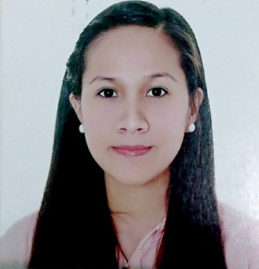
Judy, RMT, HAAD RMT, ASCPi
C/o-Contact number: +971501685421
Email: judy.379360@2freemail.com

OBJECTIVE: I aspire to find platform where I can make use of my skills and understanding regarding laboratory medicine and help me grow in performing test in the laboratory setting as a Medical Technologist.

LICENSES:

Title: Medical Laboratory Technologist
Institution: Health Authority Abu Dhabi

Title: Medical Laboratory Scientist
Institution:American Society of Clinical Pathology Member

Title: Medical Technologist
Institution: Philippine Regulatory Commission

PROFESSIONAL EXPERIENCE:
Position: Medical Laboratory Technologist Company: Al Salama Hospital Abu Dhabi Date: June 2016 - Present
Position: Medical Technologist
Company: Our Lady of Lourdes International Medical Center
Date: October 2013- March 2016

EDUCATIONAL BACKGROUND:
Bachelor in Medical Laboratory Science
June 2008- May 2013
Saint Louis University

INTERNSHIP
Saint Louis University Clinical Laboratory
Nov. 2012- May 2013
Baguio General Hospital and Medical Center
May 2012- Nov. 2012

CLINICAL TRAINING:
Hematology and Transfusion Medicine Training Course
Date: May 2015- June 2015
Institution: National Kidney Transplant Institute Philippines

Basic Life Support- Cardiopulmonary Resuscitation with AED Training
Date: January 18 2016- January 19, 2016 Institution: Philippine Red Cross

Standard First Aid Training
Date: January 20, 2016- January 22, 2016
Institution: Philippine Red Cross

DUTIES AND RESPONSIBITLITIES:
- Perform phlebotomy task
- Observe strict asepsis technique and infection and contamination during blood drawings
- Ensure proper sample collection handling and receiving of sample.
- Perform technical laboratory analysis including blood chemistry, hematology, microbiology, microscopy, blood banking, immunology and serology.
- Log patients’ data with corresponding laboratory test profile following hospital standards.
- Ensure accuracy and precision of test results by performing both internal and external quality control
- Able to perform validation, precision and accuracy testing of the machines
- Maintain and operate laboratory equipment
- Keep inventory and ensure adequate supplies
- Adhere to hospital policies related to laboratory safety , cleanliness, infection control and proper disposal of biohazard wastes

SEMINARS:
Title: MEDLAB 2017: 16th Annual Laboratory Management and Medicine Conference Date: February 9, 2017 Dubai International Convention and Exhibition Centre, Dubai, UAE
Title: Consultative Meeting for Blood Coordinators and Stakeholders
Date: Feb. 23, 2015- Feb. 24, 2015
San Fernando City, Pampanga, Philippines

Title: Blood Bank Myths II: The Blood Donor Edition
Date: August 18, 2015
Crowne Plaza Quezon City, Philippines

Title: 32nd Annual Convention of the Philippine Blood Coordination Council Reducing Risks for Transfusion Safety Date: August 18, 2015- August 20, 2015 Crowne Plaza Quezon City, Philippines

