GAUTHAM  Email : gautham.379369@2freemail.com | 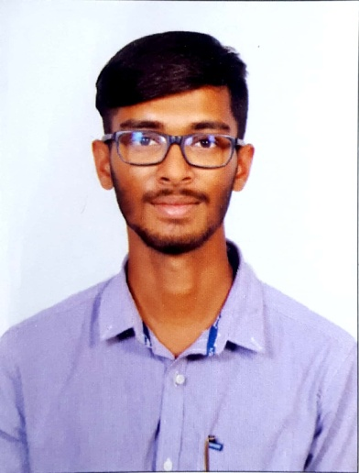
OBJECTIVE | To work for an organization which provides me the opportunity to improve my skills and knowledge to growth along with the organization objective.
SUMMARY | I consider myself a responsible, creative, with initiative and punctuality, I accept with pleasure the challenges and goals that your organization could assign me, with good handle of the interpersonal relationships, ability to work in teams, ability to work under high pressure, so as to solve problems efficiently and achieve the goals set by the company and my work group.
EDUCATION | National Institute Of Open Schooling  Secondary School 2014- 2015  Diploma in Visual Effects 2015-2016  I have completed my Diploma in RedBoxx1 (visual Effects) on 2016 under Frameboxx Institute
WORK EXPERIENCE | BUXUS MEDIA Pvt Ltd, HSR Layout, Bangalore. 2016  I had been working in a Bangalore based company called Buxus Media for June 2016 as SR Executive- operation. Buxus is a fully integrated BTL service provider, specialized in Corporate Events, Conferences, Promotions and Sports Events.
PROFESSIO-NAL SKILLS | Management & Organizational Skill  Multi Tasking  Computer Skill  Team Work Skill  Honest and Sincere
LANGUAGE  KNOWN | ENGLISH, KANNADA , HINDI,TELUGU,TAMIL.
PERSONAL  INFORMATION | Date of Birth : 11/05/1997  Sex : Male  Martial status : Unmarried  Nationality : Indian  Blood Group : B+
Gautham

